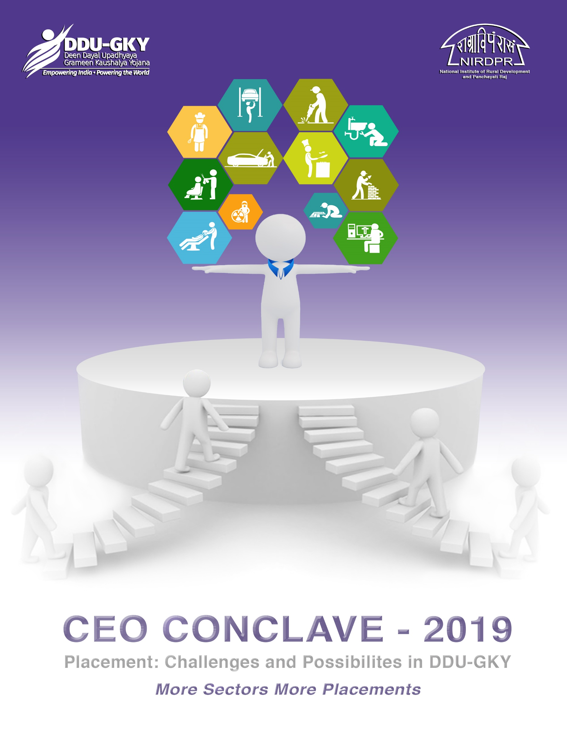

26-27 August, 2019

Table of Contents
AGENDA 1
List of Participants of CEO Conclave 2019 at Pragati Resort 5
The Context 7
Session 1: Welcome Address by Director (T&D) Dr. Sandhya Gopakumaran 7
Session 2: Unveiling the Theme of the Conclave by Dr. W. R Reddy, I.A.S, Director General, NIRDPR 7
Session 3: Key Note Address and Expectations by Director General, Dr. W. R Reddy 8
Videos recommended by the Director General for watching: 10
1. What is 4th Industrial Revolution: 10
2. 15 Jobs That Will Disappear In The Next 20 Years Due To AI 10
Session 4: Trainer Felicitation: Awarding of Certificates to “Kaushal Praveen” ToT Accredited PIA Trainers by the Director General, Dr. W. R Reddy & Joint Director Skills (MoRD) Shri Sandeep Sharma 11
Session 5: Positioning DDU-GKY in Rural Employment Scenario 11
Chair: Shri Ajay Kumar Sharma, IAS, CEO, Madhya Pradesh 11
Speaker 1: Dr. Partha Pratim Sahu, Associate Professor, Centre for Entrepreneurship Development, NIRDPR 11
Session 6: Skill Development and Placement in Agricultural Sector for DDU-GKY 12
Speaker 2: Shri K. Venkateswara Rao, Managing Director, NABCONS 12
Session 7: Placement Challenges in DDU-GKY: A CTSA perspective 12
Chair: Shri M Maheswar Reddy, CEO, Andhra Pradesh 12
Speaker 1: Shri Shankar Dutt Kabdal, Director - M&E, DDU-GKY, NIRDPR 12
Speaker 2: Shri B K Tripathy, Vice President, NABCONS 17
Remarks by the Chair: Shri M Maheswar Reddy, CEO, Andhra Pradesh 18
Session 8: Distance covered from CEO Forum 2018 18
Speaker: Shri K. R. Padmanabha Rao, Addl. Project Director, DDU-GKY, NIRDPR 18
Session 9: New Possibilities for Skilling & Placement in DDU-GKY - Voice of Sector Skill Councils and Industry Partners under Niche & Emerging Areas 20
Chair: Shri Praveen P. Nair, IAS, Mission Director, Tamil Nadu 20
Speaker 1: Shri Vinod Behari, CEO, Power Sector Skill Council (PSSC) 20
Speaker 2: Dr. Parveen Dhamija, Advisor, Skill Council For Green Jobs (SCGJ) 22
Speaker 3: Shri Tarun Parihar, Head Corporate Matters & Projects, Skill Council for Persons with Disability (SCPWD) 22
Speaker 4: Smt. Shalini Singh, COO, Capital Goods Skill Council (CGSC) 24
Speaker 5: Shri Jagdish Acharya, CEO, Paints & Coatings Skills Council (PCSC) 25
Speaker 6: Shri Siddhartha Banerjee, Consultant, Management & Entrepreneurship and Professional Skills Council (MEPSC) 27
Remarks by the Chair: Shri Praveen P. Nair, IAS, Mission Director, Tamil Nadu 28
Session 10: Voice of Sector Skill Councils and Industry Partners under Existing Areas & New Possibilities 28
Chair: Shri Unice Rishin Ismail, IAS, Joint Secretary, Department of Technical Education Training & Skill Development, West Bengal 28
Speaker 7: Shri Sundeep Chhabra, National Head, Tourism and Hospitality Skill Council (THSC) 28
Speaker 8: Shri Meghdoot Karnik, COO, Banking Financial Services & Insurance Sector Skill Council (BFSI) 31
Speaker 9: Shri Arun Lakshman, Industry Expert, Automotive Skills Development Council (ASDC) 32
Remarks by the Chair: Shri Unice Rishin Ismail, IAS, Joint Secretary, Department of Technical Education Training & Skill Development, West Bengal 33
Session 11: Musings on Finance & Appraisal 33
Speaker: Dr. M. Srikanth, Director, Appraisal & Finance, DDU-GKY & Associate Professor & Head, Centre for Financial Inclusion & Entrepreneurship, NIRDPR 33
Session 1: Health Talk by Shri GBK Rao, CMD, Pragati Resorts 34
Session 2: Kaushal Bharat 34
Speaker: Shri Samir Goswami, Director - MIS, DDU-GKY, NIRDPR 34
Session 3: Address by Guest Honour Shri Charanjit Singh, Joint Secretary (Skills), MoRD 36
Session 4: Release of New Initiatives of DDU-GKY designed by Training Division NIRDPR 37
Session 5: Exploring Convergence for Better Placement and Retention of Rural Youth 38
Chair: Smt. Nandita Hazarika, ACS, Mission Director, Assam 38
Best Practices from Tata Strive 38
Speaker: Shri Bhaskar Natarajan, Head Programme Execution 38
Session 6: Leveraging convergence opportunities to strengthen DDU-GKY 38
Speaker: Shri S.Harikishore, IAS, Executive Director, Kerala 38
Session 7: Convergence with Panchayati Raj for better Mobilization Outcomes 40
Speaker: Dr. C. Kathiresan, Associate Professor & Head, Centre for Panchayati Raj, NIRDPR 40
Session 8: 5 bold steps for the next 6 months, gaps identified and support required from MoRD and NIRDPR 43
Group - 1 44
Discussion Points 44
Group - 2 45
Action Points 45
Group - 3 46
Bold Steps for the next few months 46
Group - 4 46
Recommendations - Way Forward 46
Session 9: Best Practices and Challenges in Placement – Voice of the States 49
Chair: Dr. B. R. Mamatha, IAS, Mission Director, Karnataka 49
Remarks by the Chair: Dr. B R Mamatha, IAS, Mission Director, Karnataka 50
Session 10: Recommendations from MoRD by Shri Charanjit Singh, Joint Secretary (Skills), MoRD 51
Session 11: Concluding Remarks and Way Forward by Director General, Dr W. R Reddy 51
Session 12: Felicitation of Guests 52
Vote of Thanks by Shri Shankar Dutt Kabdal, Director - M&E, DDU-GKY, NIRDPR 52
Appendix 53

AGENDA
Day 1: 26th August 2019
Time | Topic | Speaker/ Panelist
Inauguration
Rapporteurs: Afrozuddin MD & Rishi Upadhyay (DDU-GKY Team, NIRDPR)
09:15 – 09:40 | Registration and Networking
09:40 – 09:45 | Welcome Address | Dr. Sandhya Gopakumaran,  Director - T&D,  DDU-GKY, NIRDPR
09:45 – 10:00 | Unveiling the Theme of the Conclave | Dr. W. R. Reddy, IAS,  Director General, NIRDPR
 | Key Note Address and Expectations
10:00 – 10:15 | Trainer Felicitation: Awarding of Certificates to “Kaushal Praveen” ToT Accredited PIA Trainers | Dr. W. R. Reddy, IAS,  Director General, NIRDPR  &  Shri Sandeep Sharma  Joint Director Skills (MoRD)
Chair: Shri Ajay Kumar Sharma, IAS, CEO, Madhya Pradesh
10:15 – 10:45 | Positioning DDU-GKY in Rural Employment Scenario | Dr. Partha Pratim Sahu,  Associate Professor,  Centre for Entrepreneurship Development, NIRDPR
10:45 – 11:00 | Group Photo and Tea Break
11:00 – 11:30 | Skill Development and Placement in Agricultural Sector for DDU-GKY | Shri K. Venkateswara Rao, Managing Director, NABCONS
Chair: Shri M Maheswar Reddy, CEO, Andhra Pradesh
Rapporteur: Arpan Banerjee & Manoj Ekka (DDU-GKY Team, NIRDPR)
11:30 – 12:15 | Placement Challenges in DDU-GKY: A CTSA perspective | Shri Shankar Dutt Kabdal, Director - M&E,  DDU-GKY, NIRDPR  &  Shri B K Tripathy,  Vice President, NABCONS
12:15 – 12:30 | Remarks by the Chair | Shri M Maheswar Reddy, CEO, Andhra Pradesh
12:30 – 13:00 | Distance Covered from CEO Forum 2018 | Shri K. R. Padmanabha Rao, Addl. Project Director,  DDU-GKY, NIRDPR
13:00 – 13:45 | Lunch Break

Panel Discussion: New Possibilities for Skilling & Placement in DDU-GKY: Voice of Sector Skill Councils and Industry Partners
Chair: Shri Praveen P. Nair, IAS, Mission Director, Tamil Nadu
Rapporteurs: M Naveen Kumar, Surajit Sikdar, Padma Lata & Pooja Shaw (DDU-GKY Team, NIRDPR)
13:45 – 15:15 | Niche & Emerging Areas:  - Skill Council for Persons with Disability  - Skill Council For Green Jobs  - Power Sector Skill Council  - Capital Goods Skill Council  - Paints & Coatings Skills Council  - Management & Entrepreneurship and Professional Skills Council | Shri Tarun Parihar, Head Corporate Matters & Projects  Dr. Parveen Dhamija, Advisor  Shri Vinod Behari, CEO  Smt. Shalini Singh, COO  Shri Jagdish Acharya, CEO  Shri Siddhartha Banerjee, Consultant
15:15 – 15:30 | Remarks by the Chair | Shri Praveen P. Nair, IAS,  Mission Director, Tamil Nadu
Chair: Shri Unice Rishin Ismail, IAS, Joint Secretary, Department of Technical Education Training & Skill Development, West Bengal
15:30 – 16:15 | Existing Areas and New Possibilities:  - Tourism and Hospitality Skill Council  - Banking Financial Services & Insurance Sector  - Automotive Skills Development Council | Shri Sundeep Chhabra,  National Head Training & State Engagements  Shri Meghdoot Karnik, COO  Shri Arun Lakshman,  Industry Expert
16:15 – 16:30 | Remarks by the Chair | Shri Unice Rishin Ismail, IAS,  Joint Secretary, Department of Technical Education Training & Skill Development,  West Bengal
16:30 – 16:45 | Tea Break
16:45 – 17:00 | The way forward | Dr. W. R. Reddy, IAS,  Director General, NIRDPR
17:00 – 17:15 | Break
17:15 – 17:45 | Musings on Finance & Appraisal | Dr. M. Srikanth,  Director - Appraisal & Finance, DDU-GKY &  Associate Professor & Head,  Centre for Financial Inclusion & Entrepreneurship, NIRDPR

Day 2: 27th August 2019
Time | Topic | Speaker/ Panelist
06:30 – 07:30 | Nature Walk | Pragati Resorts
09:15 – 09:30 | Health Talk | Shri GBK Rao, CMD,  Pragati Resorts
09:30 – 10:00 | Kaushal Bharat | Shri Samir Goswami,  Director - MIS,  DDU-GKY, NIRDPR
10:00 – 10:15 | Q&A
10:15 – 10:30 | Address by Guest of Honour | Shri Charanjit Singh,  Joint Secretary (Skills), MoRD
 | Release of New Initiatives of DDU-GKY designed by Training Division
Exploring Convergence for Better Placement and Retention of Rural Youth
Chair: Smt. Nandita Hazarika, ACS, Mission Director, Assam
Rapporteurs: A R Amarnath & Rishi Upadhyay (DDU-GKY Team, NIRDPR)
10:30 – 11:00 | Best Practices from Tata STRIVE | Shri Bhaskar Natarajan,  Head Programme Execution
11:00 – 11:15 | Q&A
11:15 – 11:30 | Tea Break
11:30 – 12:00 | Leveraging convergence opportunities to strengthen DDU-GKY | Shri S. Harikishore, IAS,  Executive Director, Kerala
12:00 – 12:30 | Convergence with Panchayati Raj for better Mobilization Outcomes | Dr. C. Kathiresan,  Associate Professor & Head,  Centre for Panchayati Raj, NIRDPR
Group Discussion: 5 bold steps for the next 6 months, gaps identified and support required from MoRD and NIRDPR
Group 1 Rapporteur: Arpan Banerjee & Ranghey Raghaw, Afrozuddin MD
Group 2 Rapporteur: Jeevan Reddy & Shashidhar Doodi (DDU-GKY Team, NIRDPR)
12:30 – 13:00 | Syndicate Group Discussion:  5 bold steps for the next 6 months, gaps identified and support required | Syndicate Group 1  Discussion Lead:  Shri S. Harikishore, IAS,  Executive Director, Kerala  Syndicate Group 2  Discussion Lead:  Shri Rajiw Kumar, IAS  Mission Director, Jharkhand
13:00 – 13:15 | Presentation: Group 1 | Group 1 Representative
13:15 – 13:30 | Presentation: Group 2 | Group 2 Representative
13:30 – 14:15 | Lunch Break

Best Practices and Challenges in Placement: Voice of the States
Chair: Dr. B. R. Mamatha, IAS, Mission Director, Karnataka
Rapporteurs: Arpan Banerjee & Ranghey Raghaw (DDU-GKY Team, NIRDPR)
14:15 – 15:00 | Presentation by States  Assam, Andhra Pradesh, Bihar, Chhattisgarh, Gujarat, Haryana, Jharkhand, J&K, Karnataka | SRLM
15:00 – 15:30 | Presentation by States Cont.  Kerala, Madhya Pradesh, Maharastra, Manipur, Odisha, Rajasthan, Tamil Nadu, Telangana, Uttar Pradesh, West Bengal | SRLM
15:30 – 15:45 | Remarks by the Chair | Dr. B R Mamatha, IAS,  Mission Director, Karnataka
15:45 – 16:00 | Tea Break
16:00 – 16:15 | Recommendations from MoRD | Shri Charanjit Singh,  Joint Secretary (Skills), MoRD
16:15 – 16:30 | Concluding Remarks and Way Forward | Dr. W. R. Reddy, IAS,  Director General, NIRDPR
16:30 – 16:45 | Felicitation of Guests | DDU-GKY Team, NIRDPR
16:45 – 17:00 | Vote of Thanks | Shri Shankar Dutt Kabdal,  Director - M&E,  DDU-GKY, NIRDPR

List of Participants of CEO Conclave 2019
Sl No | Organization | Name | Designation
1 | MoRD | Shri Charanjit Singh | Joint Secretary (Skills),
2 | MoRD | Shri Sandeep Sharma | Joint Director (Skills)
3 | NRO | Shri Vinay Pandey | Head Project Management Agency
4 | NRO | Shri Tanmoy Ghatak | Programme Coordinator
5 | NRO | Shri Nitin Katmarkar | Programme Coordinator
6 | NRO | Smt. Nidhi Rawat | Deputy Head Project Management Agency
7 | NRO | Smt. Dipali Pujari | Deputy Head Project Management Agency
8 | Assam | Smt. Nandita Hazarika, ACS | Mission Director
9 |  | Shri Amrit Borah | COO
10 | Andhra Pradesh | Shri M Maheswar Reddy | CEO
11 |  | Shri D Ramesh | Executive Director
12 | Bihar | Shri Jitendra Kumar | SPM
13 |  | Shri Gyanesh Singh | SPM
14 | Chhattisgarh | Shri Abhijeet Singh, IAS | Mission Director
15 | Haryana | Shri R R Badyal | COO
16 | Jammu & Kashmir | Shri Kapil Sharma | COO
17 | Jharkhand | Shri Deepak Upadhyay | COO
18 | Karnataka | Dr. B R Mamatha, IAS | Mission Director
19 |  | Shri Vishwanath P M | COO
20 | Kerala | Shri S Harikishore, IAS | Executive Director
21 |  | Shri Shibu | In-charge COO
22 |  | Shri Jayan | SPM
23 | Madhya Pradesh | Shri Ajay Kumar Sharma, IAS | CEO
24 |  | Shri K K Shrivastva | COO
25 |  | Shri Dhirendra Singh | SPM
26 | Maharastra | Smt R Vimala, IAS | CEO
27 | Manipur | Shri Kh. Bobby Singh | SMM-Skills
28 | NABCONS | Shri K Venkateswara Rao | Managing Director
29 |  | Shri B K Tripathy | Vice President
30 |  | Smt. Sushma Kaw | Project Coordinator
31 | Odisha | Shri Badal Kumar Mohanty | Joint CEO
32 |  | Shri Omprakash Rautaraya | Deputy CEO
33 | Punjab | Shri Rahul Tiwari, IAS | CEO
34 | Rajasthan | Shri Yogamitra Dinkar | COO
35 | Tamil Nadu | Shri Praveen P Nair, IAS | Mission Director
36 |  | Shri Ganesh Kanna | COO
37 |  | Shri Vinoth Prabhakar | SPM
38 | Telangana | Shri Madhukar Babu | Executive Director
39 | Uttar Pradesh | Shri D K Verma | Deputy Director
40 |  | Shri Anuj Yadav | SPM
41 |  | Shri Asheesh Sinha | State Coordinator - TSA
42 | West Bengal | Shri Unice Rishin Ismail, IAS | Joint Secretary, Department of Technical Education Training & Skill Development
43 |  | Shri Arnab Bathacharya | SPM
44 | Automotive Skills Development Council (ASDC) | Shri Arun Lakshman | Industry Expert & South Regional Head
45 | Paints & Coatings Skills Council (PCSC) | Shri Jagdish Acharya | CEO
46 | Power Sector Skill Council (PSSC) | Shri Vinod Behari | CEO
47 | BFSI Sector Skill Council | Shri Meghdoot Karnik | COO
48 | Tourism and Hospitality Skill Council (THSC) | Shri Sundeep Chhabra | National Head- Training & State Engagements
49 | Capital Goods Skill Council (CGSC) | Smt. Shalini Singh | COO
50 | Management & Entrepreneurship and Professional Skills Council (MEPSC) | Shri Siddhartha Banerjee | Consultant
51 | Skill Council For Green Jobs (SCGJ) | Dr. Parveen Dhamija | Advisor
52 | Skill Council for Persons with Disability (SCPWD) | Shri Tarun Parihar | Head – Corporate Matters and Projects
53 | Tata STRIVE | Shri Bhaskar Natrajan | Head Programme Execution
CEO CONCLAVE 2019: THE CONTEXT
Day 1: 26 August 2019

The Context
A conclave of the CEOs and COOs of SRLMs for DDU-GKY was hosted by DDU-GKY, Centre for Skills & Jobs, NIRDPR on 26-27 August 2019 at Pragati Resorts, Hyderabad. The theme of the conclave was Placements: Challenges and Possibilities.
In the "Strategy for New India@75”, one of the main goals for 2022-23 in skilling is to increase the proportion of formally skilled workers from the current 5.4 per cent of India’s workforce to at least 15 per cent. As the states are poised to meet the new targets for skilling the rural youth of our country during this financial year (2019-20), DDU-GKY (Deen Dayal Upadhyay Grameen Kaushalya Yojana), a flagship programme of the Ministry of Rural Development, has a phenomenal role to play in achieving these goals. Data indicates certain trends in “youth idleness” and shows that 27% of youth population in rural India in the age group of 15-29 years are in the category of NEET (Not in Employment, Education or Training) (Annual Report: Periodic Labour Force Survey (PLFS) 2017-18).
DDU-GKY can bring out the youth to get skilled and get employed adequately. Therefore, as a time right to draw upon our synergies and address the issues, concerns and challenges associated with placement in DDU-GKY in this context and to tap into tremendous possibilities NIRD & PR hosted this CEO Conclave.

Session 1: Welcome Address by Director (T&D) Dr. Sandhya Gopakumaran
On behalf of the Centre for Skills & Jobs, DDU-GKY NIRDPR, the following august audience of the conclave were welcomed: The Hon’ble Director General Dr. W.R Reddy, IAS, the Deputy Director (Skills) MoRD Shri Sandeep Sharma, CEOs of SRLMs, Managing Director, NABCONS, Vice President, NABCONS, Executive Directors, Joint CEO, Deputy CEO, COOs of DDU-GKY SRLMs, SPMs, TSA, CEOs of SSCs, NIRDPR Professors, PIA Trainers and DDU-GKY staff were welcomed to the Forum.

Session 2: Unveiling the Theme of the Conclave by Dr. W. R Reddy, I.A.S, Director General, NIRDPR
The Director General of NIRDPR unveiled the theme of the conclave: Placement – Challenges and Opportunities in DDU-GKY.
(Click here to view the presentation)
Simon Sinek, the thought leader and influencer said that any effort that we make is punctuated by three questions, the what, the why and the how. Of the three questions, the why stands at the heart of everything.
The “why” of DDU-GKY is our candidates who are trained and placed to help them earn sustainable livelihood.
The candidates who have been recently placed in the Hospitality sector at the venue of the Conclave M/S Pragati Resorts were welcomed to the conclave and felicitated.

Session 3: Key Note Address and Expectations by Director General, Dr. W. R Reddy
It is a cliché now to say that we are living an age of disruption. Industrial Revolution 4.0 is marked by Artificial Intelligence taking over repetitive jobs, gig economy, informal jobs and economic upheavals.
According to the Global Human Capital Trends Survey 2019 by Deloitte, it is a critical time for the industry to reinvent itself with human focus, given the trends above. It also predicts lifelong learning for employees.

It is also time then, that we reinvented ourselves both from a DDU-GKY and rural skilling angle, and not just from the human capital trends perspective, but also because there is a mosaic of aspirations, confusion, disenchantments for our rural youth – or what seems to be a problem of too many (multiple schemes) or too few options to choose from (offering the same). The conventional boundaries between formal and informal jobs, salary, wage and payment; all of these seem to blur. These days we find a youth migrated from a remote village to a city as well as an IT professional – both - driving Uber or Ola cabs and earning their money. Even when we say there are no “jobs”, we see that people are earning differently. So what would all this mean to us in rural youth skilling context, how do we respond to the changing times here.
- There is a 27% of youth in the NEET category in India in the age group of 18-29; this is going to put them back in the brink of poverty later
- Trained students are unwilling to migrate outside their states/districts for jobs, they tend to return.
- The salary is not sufficient to sustain themselves in the city, thereby defeating the purpose of sustainable livelihood.
- Therefore, apart from the popular discourse of reaping demographic dividend of rural youth for filling the skill and demographic deficit elsewhere in the world, we cannot ignore the fact that rural youth are also exercising certain choices. Therefore, they need to be gainfully engaged in rural development sectors, in their own states by skilling them.
- Special Focus on opportunities for youth in the North East, need to look at local opportunities
- Special Focus on opportunities for differently abled, how can we equip PIAs. Currently there are only about 2-3 PIAs who have undertaken this project
- Skilling practices to be more dynamic according to industry expectations
Essentially, the narrative is complex, however, for us it means that, rural youth would like to exercise choices and that we have to look at multiple options and offer youth with a smorgasboard of irresistible choices. One reason for my saying it is as below:

Top 5 projects in DDU-GKY are in the following sectors currently, where the option points to migration:

- Accounts and Tally
- Retail
- Hospitality
- SMO
- BPO

Accordingly, in this conclave, we have invited CEOs and Experts from the following 09 Sector Skill Councils who, from a DDU-GKY perspective, fall in the following categories from a DDU-GKY perspective:
- Existing: Hospitality, BFSI, Automotive
- Emerging: Capital Goods, Power Sector Skills Council, Paints and Coatings, Management & Entrepreneurship and Professional Skills Council (MEPSC)
- Niche: Persons with Disability Skills Council and Green Jobs
In category 1 "existing", we would like to explore new opportunities that can support skilling and placements and how can SSCs and industry work with us in the ecosystem to enable those.

Automotive: For tractors, earth movers, electric vehicles, two wheeler repairing. The questions to them are, how to formalize repairers' employment? and design their training accordingly? what help can SSC extend?

In category 2 "emerging", we would like to explore how rural candidates can be suitably skilled to work in the Agricultural Machinery sectors; how new experiments in skilling can be initiated with industry partnerships, what kind of agreements can be entered into, etc.

In category 3 "niche", we would like to know how PwD SSC is facilitating the skilling and placement of PwD candidates. How can we attract more PIAs into DDU-GKY for this. In terms of Green Jobs, we wish to explore convergence with MNRE, CII and the SSC, so that youth can be employed under "Smart Gram Initiative".

We are looking at concrete outcomes from this discussion, so that there are at least 4-5 action points for the forum of CEOs and NIRD to work on; and DDU-GKY becomes an active option for these SSCs for getting skilled youth and engaging them in rural development.
Another critical point is the need for convergence to be able to innovate and deepen our impact. The quality of mobilization will improve the quantity of placements.
Convergence with Nehru Yuva Kendra, Social Welfare Ministry, NRLM and Panchayati Raj can improve the quality of mobilization significantly.
We have made a beginning – in the month of May, members from Nehru Yuva Kendra have expressed a deep interest in working with DDU-GKY during the consultative workshop on counselling skills. Incidentally that is an important area that can give youth a direction to carve their future. NIRDPR has designed two courses in counselling a certificate course and a fast track course which will be rolled out in a couple of months. There are at least 4 institutions that have been identified as potential resource centres that will be the hub for this training.
In this conclave, we are also exploring how Panchayati Raj can be leveraged to improve the quality of mobilization, which will in turn can improve the quality of placements.
We are also going to hear how some of the experiments in Kerala and Manipur with regard to convergence have reaped benefits.
We would like you to look at DDU-GKY at NIRDPR not just as a CTSA, but as a Centre for Skills and Jobs, as your space to converge, meet and reinvent rural youth skilling and for improving their livelihood opportunities and securing their future.
From the first conclave held in April 2018, there were recommendations received from the states which NIRD has worked on, which will be shared in a session today.
This conclave, let us work more closely together to make a significant impact on rural youth skilling.
We hope this Conclave will not only be a good platform for dialogue and deliberations, but also a point where new strategic initiatives begin for 2019 and beyond.

Videos recommended by the Director General for watching:
1. What is 4th Industrial Revolution: https://www.youtube.com/watch?v=kpW9JcWxKq0
2. 15 Jobs That Will Disappear In The Next 20 Years Due To AI: https://www.youtube.com/watch?v=r211u89eUaY

Session 4: Trainer Felicitation: Awarding of Certificates to “Kaushal Praveen” ToT Accredited PIA Trainers by the Director General, Dr. W. R Reddy & Joint Director Skills (MoRD) Shri Sandeep Sharma
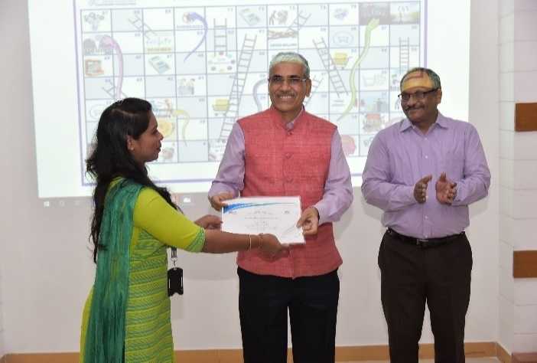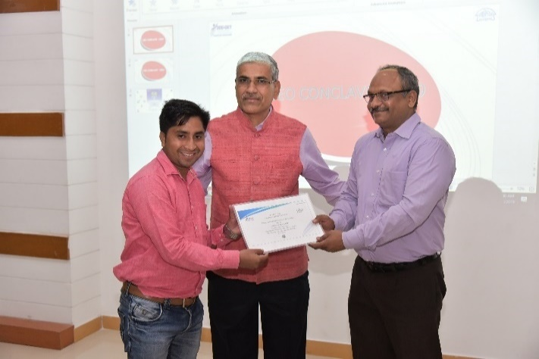
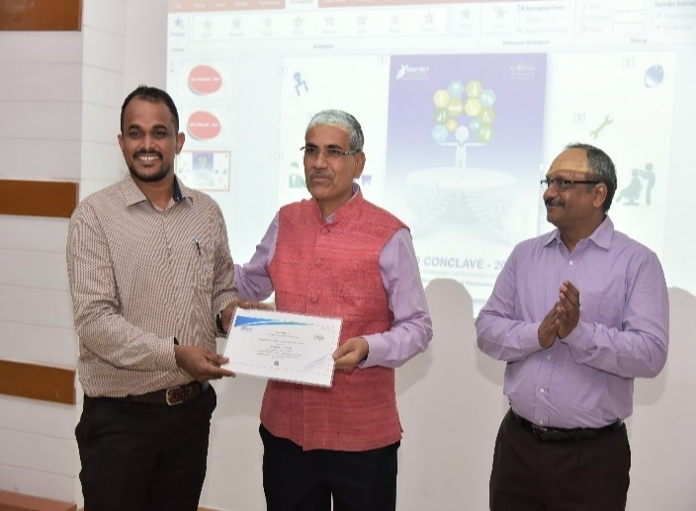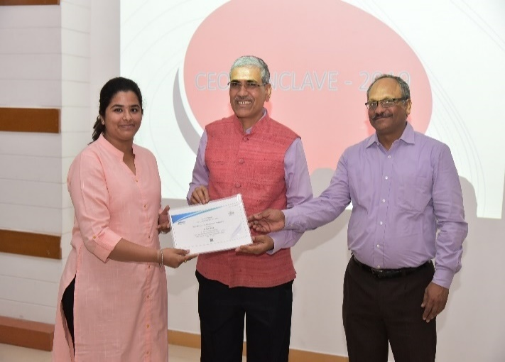
Trainers receiving Accreditation Certificate from Dr. W. R Reddy, IAS, Director General, NIRDPR and Shri. Sandeep Sharma, Joint Director (Skills), MoRD
A newly designed Snake and Ladder Game for Retail was released where the game was first initiated by rolling the dice between the Director General NIRDPR and Joint Director MoRD; the entire audience commenced the game from their respective tables. The game will be made available on NIRDPR LMS for the use of the Trainers in Retail. This game was conceptualized by one of DDU-GKY retail trainers in Andhra Pradesh, designed and developed in NIRDPR.

Session 5: Positioning DDU-GKY in Rural Employment Scenario

Chair: Shri Ajay Kumar Sharma, IAS, CEO, Madhya Pradesh

Speaker 1: Dr. Partha Pratim Sahu, Associate Professor, Centre for Entrepreneurship Development, NIRDPR
Refer to Appendix one for the powerpoint
Dr. Partha Pratim Sahu, Associate Professor, Centre for Entrepreneurship Development highlighted the quantitative and qualitative dimensions of employment challenges, the reasons for the same, the rural employment scenario and challenges in the larger labour market context. Dr. Sahu recommended that there should be frequent impact studies, convergence of skilling programmes and placing DDU-GKY in the larger skilling space, and promotion of apprenticeship opportunities as some of the factors to enable DDU-GKY succeed more. He also emphasized the need to focus on emerging sectors more.

Session 6: Skill Development and Placement in Agricultural Sector for DDU-GKY

Speaker 2: Shri K. Venkateswara Rao, Managing Director, NABCONS
Refer to Appendix two for the powerpoint
Shri K Venkateswara Rao, MD NABCONS shed light on placement opportunities in the agricultural sector for DDU-GKY. The different job roles in Agri sector where youth can be skilled was highlighted. He pointed out the potential for privatisation in the farming sector and that would mean not just enhanced efficiency, but more jobs for rural youth.

Session 7: Placement Challenges in DDU-GKY: A CTSA perspective

Chair: Shri M Maheswar Reddy, CEO, Andhra Pradesh

Speaker 1: Shri Shankar Dutt Kabdal, Director - M&E, DDU-GKY, NIRDPR

Refer to Appendix three for the powerpoint
The Speaker shared his experience on DDU-GKY being in a much better position compared to other skill development schemes in terms of quality, delivery, and standards. However the scheme faces some challenges because of failing to achieve the 70% of minimum placement criteria.
The Speaker then defined what placement in DDU-GKY stands for:
- Offer letter of Employment
- Continuous employment for minimum of 3 months
- Minimum Wages valued as per Cost to Company (CTC)
- Documentary Evidences in support of proof of placement i.e., copy of offer letter, Salary Slips and Bank Statements
The speaker also explained the minimum salary requirement for the candidates based on the course duration for eg., Rs. 6000/- for 3 months course duration, Rs. 9000/- for 6 months course duration, Rs. 12,000/- for 9 months course duration and Rs. 15,000/- for 12 months course duration or the minimum wages of the state for the semi-skilled resources as per the Minimum Wage Act, whichever is higher.

Key statistics (as on 5th August, 2109) presented by the speaker regarding DDU-GKY:
Sl. No. | Particulars | Achievements
1 | Total No. of Projects | 1265
2 | Total No. of Training Centres | 1499
3 | Action Plan Target (2019-22) | 19.61 Lakhs
4 | Total Trained | 8.60 Lakhs
5 | Total Placed | 5.27 Lakhs
6 | Total No. of PIAs | 571
7 | Under Training | 1.24 Lakhs
The Speaker presented the Quality Assurance Framework of DDU-GKY as mentioned below:
Sl. No. | QA Framework | Descriptions
1 | PIA Selection | - PRN Assignment to PIA by MoRD, Submission of online application in the designated portal by the PIA, Initial Screening followed by Qualitative Appraisal and Approval of projects through Project Approval Committee (PAC) of concerned state
2 | Guidelines & SOPs | - Standards for Physical Infrastructure, TLMs, Trainers, hostels and Placements  - SOPs for all Mobilization, Selection, Training, Assessment and Placement of trained candidates
3 | ASK – Quality Outcomes | - Soft Skills, Basic IT and Spoken English  - Skills- Domain Labs, OJT, Industry Connect/Visits  - Knowledge – Learn by Doing
4 | Use of Technology | - Authentication of candidates – geo-tagged biometric attendance  - CCTV Recording  - Tablets/PCs to each candidate  - Workflow based ERP and MIS
5 | 3-Tier M&E | - Self-regulation by PIA through Q-team  - Monitoring by state nodal agency  - Monitoring by MoRD through it’s CTSAs
6 | Deployment of Skilled Manpower | - Mandatory to clear e-SOP certification for all stakeholders involved in DDU-GKY implementation and monitoring
7 | Fund Management | - PFMS (Public Financial Management System) to disburse, track and report fund utilization
8 | Training Contents | - Training Contents – Job roles aligned to NSQF  - 1319 QP-NOS of SSCs  - 578 Modular Employable Skills (MES) courses of NCVT  - 3rd Party Assessment & Certification
The Speaker presented the Support and Incentives provided to Candidates & PIAs as mentioned below:
Sl. No. | Support & Incentives | Descriptions
1 | Post Placement Support | - Rs. 1,000/- per month for 2 months within district, 3 months within State & 6 months outside State  - Rs. 2,000/- per month for 6 months – Himayat
2 | Retention Support | - Rs. 3,000/- per candidate retained in employment for 365 days (with a break of maximum 60 days)  - 1/3rd of the cost is shared by PIA with the candidate
3 | Career Progression | - Rs. 5,000/- per person who crosses a salary of Rs.15,000/- per month and holds it for a minimum of 3 months within one year of completion of training  - 1/3rd of the cost is shared by PIA with the candidate
4 | Support for foreign Placement | - Rs.10,000/- per candidate to support Counselling including medical check-up for candidates placed in Foreign countries
5 | Mobile Tracking Cost | - Payment of Rs. 50/-per candidate per month for 12 months for mobile top up to ensure candidate tracking after placement
6 | Incentives to PIAs | - Rs.3,000/- per candidate for placement between 70% to 85%  - Rs.5,000/- per candidate for placement above 85%
The Speaker explained the challenges being faced by various stakeholders under DDU-GKY and also suggested some possibilities to overcome those challenges, those are mentioned below:
Sl. No. | Perspectives | Challenges and Possibilities
1 | Candidates | - Lack of jobs in rural areas & unwillingness of youth to relocate due to low salary, family issues, health, culture, etc.  - Drop out due to peer pressure, marriage, low salary, workplace concerns, etc.  - Mismatch between training undertaken & candidate’s talent & interest  - Absence of soft skills e.g. communication, language proficiency, attire
2 | PIAs | - Improper skill gap analysis for selecting job roles  - Faulty selection and counselling of candidates  - Lack of partnership with employers. Push based placement instead of Pull based  - See placement as additional overhead  - Leaving placement activities to the centre managers / counsellors rather than as a part of strategic plan
3 | Employers | - Gap between quality of skills required vs. available  - Lack of commitment from SSCs members for placements  - No preference for candidates trained on NSQF aligned job roles  - Labour supply more than needed and that too at lower salary
4 | Government | - Reduced labour demand due to declining economic growth  (8.2%—7.2%—6.8%)  - Continuous fall in labour participation of women (declined from 36.7% in 2005 to 26% in 2018)  - Lack of participation with PIAs in placement of candidates. Govt. & outsourcing partners?  - Delay in release of funds to PIAs  - Employers/SSCs are not involved during selection of PIAs, planning, designing and execution of training  - Absence of an effective LMIS

- DDUGKY program is faring when compared to other Skill Programs in India in terms of quality
- Still we are struggling to achieve 70% placement in DDUGKY
- Quality assurance frame work
  - Selection of right training partner
  - Awareness of Guidelines and SOP
  - ASK agenda
  - Soft skills of candidates (If required to work in any other locations)
  - 3 tier quality by PIA Q Team, SRLM and CTSA (on behalf of MoRD)
  - e-SOP Certification as mandate
  - Fund Management (PFMS) to track financial transactions
  - Training Centres quality
Challenges & Possibilities in Placement
- Candidate related
- PIA related
- Employer related
- Government / Economic related
Candidate related:
  - Lack of jobs in rural areas
  - Not willing to relocate to urban areas
  - Not able to cope with new environmental conditions
  - Environmental and food issues
  - Low salary
  - Work culture etc
  - Mismatch in trade selected in training and in the trade in placement
  - Lack of soft skills
Suggestion: Use of good mobilization strategy and aptitude test before enrolling into training
PIA related:
  - Improper Skill gap analysis (at time of submission of project proposal)
  - Lack of District-wise job analysis
  - Lack of effective candidate identification / selection of candidates
  - Lack of proper counselling and mobilization strategies
  - Employers not willing to place the candidates
  - Placement responsibilities given to trainers and centre in-charges
Suggestions:
- Proper Mobilization plan
- Head quarters of PIA to design good placement strategies instead of trainers and centre in-charges
- Employer related:
  - Missing industry matched skills
  - Lack of various SSCs for assessment and certification
  - Lack of NSQF level 4 candidates
- Government / Economic Related:
  - Placement of Women
  - Release of funds to PIAs
  - Employers not involved in the selection process of PIAs
Suggestions:
- Industries to be invited to become partners
- Employers to train the candidates according to their requirements
- Captive employers to be increased
- Link with National Apprentice Scheme

Speaker 2: Shri B K Tripathy, Vice President, NABCONS

Refer to Appendix four for the powerpoint
The speaker gave suggestions to overcome some of the placement issues as mentioned below:
- More preference and involvement of Champion as well as Captive Employers to be given to improve the placement achievements
- There should be existence of placement cell at both CTSA and State/SRLM level. Moreover, SSCs should also have their own placement cell to enhance placement opportunities in DDU-GKY
- Promote Industrial Internship for better quality training and placements
- More CXO Meet and Industry Connect Workshops needs to be organised to draw the attention of the industrial partners on DDU-GKY trained candidates to provide them placement opportunities
Finally, he briefed about the importance of Kaushal Panjee and its use in effective mobilization of candidates
Feedback/Suggestions from the participants:
- Candidates have high aspirations of jobs with high salaries. Hence, revision of minimum salary criteria needs to be looked into.
- PIA/State should come up with some mechanism to draw a road map on the long term journey of candidates after training completion
- Involvement of middle-men hampers the quality of the programme. This needs to be minimised.
- Involvement of GPs in mobilization will help the candidates enrol, train and retain themselves
- Develop voice call centre to track candidates after being offered placements
Placement challenges
- Not knowing the candidates interest
- Candidates aptitude
- Low paid salaries
- PIAs not taking important job roles which require huge infrastructure instead going with low infrastructure job roles
Suggestions:
- Training need analysis with SRLMs & PIAs
- Salaries for non-domain trainers
- Huge demand of Skilled persons to maintain 24X7 uptime electricity distribution
- Huge requirement of skilled electricians in network distribution
- Quality training and certification in electrification courses
- Focus on Green jobs
- Promotion of Green energy
- Nomenclature of job roles under Green jobs to be changed to attract youth

Remarks by the Chair: Shri M Maheswar Reddy, CEO, Andhra Pradesh
- Thousands of money expended by giving residential facilities to the students but not getting desired outcome due to placement challenges and possibilities need to explore
- Biggest placement challenge is that the candidates are forced to the choose the courses or the job roles which they are not interested
- Not doing aptitude test like TATA Strive
- The low paid jobs not getting desired results
- As per MoRD report the attrition rate is high from 37 % to 97 %
- PIAs not taking up the important job roles which are infrastructure oriented rather they are choosing easy job roles like bedside assistant or sewing machine. Need to push PIAs forward to get better results.

Session 8: Distance covered from CEO Forum 2018

Speaker: Shri K. R. Padmanabha Rao, Addl. Project Director, DDU-GKY, NIRDPR
Refer to Appendix five for the powerpoint
The Speaker briefed the participants about the expectations and needs that were desired by the CEOs during the conclave held previously in the year 2018 and the distance covered by NIRDPR in achieving those desired expectations and needs during the last year.
As the outset, the speaker briefed the needs shared by CEOs at the Conclave 2018 as mentioned below:
- S0P compliant MIS/ERP aligned system
- Common IT platform, and real time data capturing
- Providing quality training to candidates
- Need for qualified trainers, Certification, Standardization of Quality and Salary of trainers
- Capacity Building of all Stakeholders
- Proper mobilization to select right candidate
- Recovery of funds from Non-performing PIAs
- Guidelines on Foreclosure of Project
- Allocation of Targets on State’s demography and tailored IT system
- MRIGS Issues (Service provider stopped the services for Appraisals logins)
- Delay in Training Commencement – Infrastructural Issues
- Delay in 3rd party Assessment/Certification

Contribution by NIRDPR during Financial Year 2018-19:
Sl. No. | Area of Contributions | Objectives | Descriptions
1 | Kaushal Bharat | Establish a SoP compliant MIS/ERP aligned system | - NIRDPR developed SOP compliant MIS/ERP aligned system to capture real time data with integrated reporting  - MoRD issued Notification – 7/2019  - State may use this at free of cost  - http://www.kaushalbharat.gov.in
2 | Proposal Management System | Establish an SOP compliant MIS/ERP aligned system | - The prospective Project Implementation Agency can apply for project and can submit online application  - https://erp.ddugky.info/login/
3 | Learning Management System | Provide quality training to candidates | - E-learning modules on SOP  - E-learning modules on Key domains  - Learning path for functionaries based on competency matrix  - Centralized content  - http://lms.nirdpr.in/
4 | Training of Trainers | Build up the Capacity of Trainers | - Notification No. 61/2017 2.iii requires NIRDPR to conduct Training of Trainers & match it with industry standards  - Kaushal Praveen: Training of Trainers on skilling methodology  - Demand-based Domain refreshing programme for States in co-ordination with SSCs  - ToT for PFMS  - ToT for Mobilisation (CRP, GRS, JRP, SHG) (draft)  - ToT on Counselling - Certificate course and short-term course (draft)
5 | Training Need Analysis with PIAs & SRLMs | Training & Capacity Building | - Training Needs Analysis with PIAs and SRLMs & Annual training calendar published  - On-demand training planned and delivered, data shared with states  - Training calendar for every month published, online registrations enabled  - DDUGKY, NIRDPR is offering training programmes to different stake holders.  - Skill DEED, a certificate programme for grooming Skill Development professionals designed for JSLPS
6 | Interventions | Standardizing trainer quality and salaries | - Salary for Non-domain Trainers calibrated with Jharkhand SRLM and the PIAs  - Advisory released by JSLPS was shared with a few states  - Pre & post measure of trainers’ ability to skill youth learners captured, trainers mentored remotely
7 | Assessments | Reduce the delay in Training Commencement & Assessments | - Placement of nodal person in MoRD & in States to coordinate with NSDC to clear the backlog and also for timely completion of Assessments in future

Session 9: New Possibilities for Skilling & Placement in DDU-GKY - Voice of Sector Skill Councils and Industry Partners under Niche & Emerging Areas

Chair: Shri Praveen P. Nair, IAS, Mission Director, Tamil Nadu

Speaker 1: Shri Vinod Behari, CEO, Power Sector Skill Council (PSSC)
Shri Vinod Behari – COO has been working in the capacity of Chief Executive Officer, Power Sector Skill Council (PSSC) since February 2015, where he has been interiliac responsible for setting up the organization, evolution of strategic road map for skilling intervention in power sector, development of National Occupational Standards (NOS) with reference to major industry job roles, and roll out of skilling initiative in response to industry needs and national priorities such as launch of skilling intervention in the context of SAUBHAGYA ( a Universal Household Electrification program).
Power Sector Skill Council (PSSC) has been promoted by Ministry of Power (MoP) through Central Electricity Authority (CEA), Ministry of New and Renewable Energy (MNRE) and Indian Electrical & Electronics Manufacturers Association (IEEMA) with necessary support by National Skill Development Corporation (NSDC). Created with a mandate to facilitate skill development across the Power Industry (covering Power Generation Transmission, Distribution, Renewal Energy and Power Equipment Manufacturing), PSSC has been actively engaged in the task to deliver on the objectives with active support of industry stakeholders.
Pursuing an ambitious target to skill, train and certify over 4 million workforce in Power Industry over decade. PSSC has developed 11 National Occupational Standards/Qualification Packs (NOS/QPs) representing major roles in power Distribution, Generation and Transmission area, while the large number of NOS/QPs are in the process of being developed.
Website: https://www.psscindia.org/
Key Points
- Power distribution requires around 85% skilled manpower of the total sector requirements
- 100% willing households are electrified through Saubhagya Yojana, which requires skilled electricians for operation and maintenance
- Course Electrician-Domestic household or equivalent required around 8 lakhs skilled manpower
- Wage employment is a challenge in the power sector, outsourcing of workers also prevents full time wage employment
- The requirement of certified electricians has not been realized by industries yet
Power distribution has the largest skilling concerns.
PSSC has identified 15 power job roles.
Through Skill Gap Study it was found that there is a huge demand in power sector either in power distribution or downstream area like individual households.
Convergence with DDU-GKY:
- There is a high demand for individual household electrician (domestic electrician) like lineman distribution, lineman construction and sub-station electrician who work for public area of power distribution. Private electrical power distributions are for individual households.
- Under Saubhagya Yojana PSSC trained 30,000 workforce across 6 states Assam, Bihar, Jharkhand, UP, MP and Odisha.
- Skill gap study signifies that roughly 6-7 lacs of incremental electricians will be serving individual households during the period of 2017-2025.
- PSSC would like to empower electricians under DDU-GKY to work towards quality training and certification under rural areas enabling them to become micro entrepreneur.
- Challenge is that only wage employment matters, self employment and micro entrepreneur does not find any place in the scheme.
- PSSC has tied up with organizations who can provide loans and household support for those people interested in self employment who want to start small electrical shop at the village creating employability.
- PSSC is working with outsourcing for wage employment.

Speaker 2: Dr. Parveen Dhamija, Advisor, Skill Council For Green Jobs (SCGJ)
Refer to Appendix six for the powerpoint
Dr. Parveen Dhamija is working as Advisor, Skill Council for Green Jobs (SCGJ), New Delhi and is involved in development of competencies /skills in the domain of renewable energy, sustainable development and waste management. She worked in Ministry of New and Renewable Energy (MNRE) for about three decades for development and deployment of renewable energy technologies.
Skill Council for Green Jobs is one of the most recently launched initiatives of the Government of India aligned to the National Skill Development Mission. Mission to identify skilling needs of service users as well as manufacturers/ service providers, within Green Businesses sector, and implement nation-wide, Industry led, collaborative skills development & entrepreneur development initiatives that will enable meet India’s potential for “Green Businesses”.
Green jobs are decent jobs that contribute to preserve or restore the environment, be they in traditional sectors such as manufacturing and construction, or in new, emerging green sectors such as renewable energy and energy efficiency. Skilling for Green jobs will help to improve energy and raw materials efficiency, limit greenhouse gas emissions, minimize waste and pollution, protect and restore ecosystems, support adaptation to the effects of climate change. SCGJ will act as a bridge between the Government of India, State Governments and industry for developing strategy & implementing programmes for Skills Development, correlated to Industry needs but also aligned to best International practices. A national level data base of skilled manpower is proposed to be created which can be directly utilized by the industry.
Website: http://sscgj.in/
Key Points
- Set up to promote green jobs across the sectors (Less materials, effective utilization and producing less wastage are the key objectives)
- 24 QPs are relevant for DDU-GKY

Speaker 3: Shri Tarun Parihar, Head Corporate Matters & Projects, Skill Council for Persons with Disability (SCPWD)
Refer to Appendix seven for the powerpoint
Shri Tarun Parihar - Head – Corporate Matters and Projects , representing SCPwD in the conclave, independently looks after, among others, all matters relating to State based Skill Development Missions and manages the state engagement activities along with corporate engagement, advocacy as also awareness through social media, skill exhibitions and other projects.
In compliance with the specific provision of the National Policy for Skill Development and Entrepreneurship 2015, Skill Council for Persons with Disability (SCPwD) was incepted as a National Body in October 2015 jointly by the Ministry of Social Justice and Empowerment (MSJE), National Skill Development Corporation (NSDC) and Confederation of India Industry (CII) under the aegis of the Ministry of Skill Development and Entrepreneurship (MSDE), Govt of India to fulfill the mission of mainstreaming ‘Persons with Disability’(PwD) through skill training under the ‘Skill India Mission’ to enable them to earn a livelihood and lead a life of dignity in the mainstream society, also in turn, contribute to the country's growing economy.
Website: http://www.scpwd.in/
Key Points
- Works with the support of the domain SSC concerned
- Conducts ToT for disability training orientation
- Certifications are arranged from domain SSC
- Conducts Training Centre Accreditation to comply the infrastructure
- Adopted 46 job roles for 4 types of disabilities so far
SCPWD works across the sector but specifically for persons with disability
SCPWD adopt job roles from the domains sector skills and map them with disability type.
There are different requirements for different disabilities like the training requirement, trainer requirement, resources and training centre accessibility etc.
Working on below mentioned 4 kinds of disabilities, these are mapped with the job role
- Locomotive Disability related to motion or movement
- Speech and Hearing Impaired
- Low Vision
- Visually Impaired
Piloting 2 more disability like Intellectual Disability (ID) and Autism Spectrum Disorder (ASD)
Conducted industry sensitization with the organizations by taking data for disability vacancies and connected to affiliated training providers for conducting placement drives
Challenges
- Unawareness of industry about the business suitable for persons with disability
- Don’t have data about the number of disabled going through training or completed training
- After completion of training who conducts the assessment?
Suggestions
- Sensitize DDU-GLY SRLM team to deal with training providers for persons with disability training
- Sensitize state related employers who are not open for conducting placement drives for persons with disability
- Recommend the employer to make necessary arrangements for disability candidates
- Can provide guidelines to MoRD and we would like to work with SRLMs

Speaker 4: Smt. Shalini Singh, COO, Capital Goods Skill Council (CGSC)
Refer to Appendix eight for the powerpoint
The Capital Goods Skill Council is a unique initiative to play proactive role and bridge the gap by creating a vibrant eco-system for quality training and skill development for the Capital Goods sector. The purpose of establishing CGSC is to ensure that the Capital Goods industry is able to grow with skilled manpower, increase productivity and profitability. CGSC is expected to create a dynamic LMIS to keep track of the labour market skill gaps, frame Occupational Standards, facilitate development of practical and high quality training content, ensure adequate availability of faculty through Train The Trainer initiatives, build accreditation and certification mechanisms and encourage capacity building through private sector participation. The key objective of the CGSC is to create a robust and vibrant eco-system for quality education and skill development in the Capital Goods Sector in the country.
Website: http://www.cgsc.in/
Key Points
- All qualifications are need based. Thus providing employment is not a challenge
- Cost norms are sufficient for meeting the training cost under the sector
- Developed 55 QPs on need based. These QPs are outcome based training programmes.
- All the QPs are validated by the industry which means CGSC have 13 industries including large and small industries.
- Production is the major focus area where maximum job roles like welding, fitters, CNC operators are available for DDU-GKY Programme.
- As per the study there is a huge demand for welders.
- CGSC focus on cluster based training.
- Based on 2018-19 assessment for DDU-GKY only 1000 candidates were assessed. The demand as per the industry is high and the kind of trainees trained is minuscule.
- CGSC requests to the Ministry to look into the job role demands available in CGSC and accordingly assign the job roles to the training partner.
- Large organizations look for placement from third party i.e MSME.
- CGSC identified 10-15 training partners and are working closely with them.
Challenges
- Training partners are not looking for Capital Goods job roles due to high end infrastructure. There is lot of investment and requirement of high end tools.
Suggestion
- Should identify serious training partners and focus on them.
- Should do skill gap study jointly with various SRLMs in a cluster based manner.
- Quality of trainer, Trainers are not aware of QPs which desires the quality of training to be done.
- Request to the Ministry is that without ToT the training programme should not be conducted.
- Look at apprenticeship model for placement and CSR projects.

Speaker 5: Shri Jagdish Acharya, CEO, Paints & Coatings Skills Council (PCSC)
Refer to Appendix nine for the powerpoint
Shri Jagdish Acharya – CEO having 40 years of Corporate experience in the Paint Industry of which 25 years were spent in International Markets of South Pacific, Australia, China and East Asia. Worked for Asian Paints from 1979 to 2016. Also, advised Asian Paints and Crompton on CSR.
Paints and Coatings Skill Council was incorporated in October 2015 under Section 8 of The Companies Act 2013 as a not for profit company. By combining standardized curriculums with sophisticated assessment tools for quality assurance, the council aims to promote and develop an ecosystem necessary to fill the skill gaps and meet the evolving challenges across all trades in the industry.
The Paints and Coatings Skill Council is committed to take steps in identifying skills needed in the coating sector, develop the National Occupational Standards for all these skills, develop the course material and training resources needed for quality training, encourage and promote the setting up of the required training institutions/academies, ensure that those who are trained in these institutions, meet the requirement of the industry.
Website: http://pcsc.in/
Key Points
- Employers are mostly into informal sector
- Bihar, UP, Tamil Nadu are the states where most candidates work in the sector
- For wage employment, we may speak to companies about their requirements.
- There is a 20% of this sector that has wage employment in wood work, marine areas.
Mission to provide the best practitioners to the coating industries.
Governing council:
- MD’s from various paints industries
- Small and medium association
- Builders
- President of Nippon is the chairman of the governing council

Different types of coating:
- Productive coating
- Marine coating
- Automotive coating
- Wood polisher
Large part of employment in the Paint & Coating is informal sector.
Identified 20 job roles, 9 in manufacturing includes Production, Quality Control, Testing Operator, Powder Coater Manufacturer
Level application includes marine coating, productive coating, application of automotive coating etc.
Curriculum approved by NSQF
Skill Gap study
- Skill gap in decorative painting applications around 4.5 lacs, wood polishing about 1.5 lacs, auto refinishing 21, 000
- General industry painter 75,000
- Productive and marine 35,000
- others 10,000
Majority of the people come from Bihar and UP. Tamil Nadu too has painters but productive and marine coating is wide spread. In rural areas there is tremendous amount of scope for mobilizing the right kind of people for taking short term courses. Lot done in RPL.
Should discuss about good short term courses. Paints & Coating can provide job role not just in decorative painting but also in marine coating where candidates can earn good livelihood or salary more than Rs 10,000 minimum per month.
In the middle east there is high demand in marine and automotive sectors.
Way Forward
The best system is visiting potential employers and inviting those industries to participate in skilling process
If state mission and SSCs organize workshops or conclaves inviting the industry representatives and tell them about what we can do, and ability to mobilize and build capacity.
SSC will bring the domain expertise and give the right kind of people. SSC will also bring better industry representatives, SRLMs can also write to them.
In such conclaves we can assure and tell that we will mobilize and provide the technical domain expertise based on the curriculum developed by us and end of the day tell us how many you want. Give the number and time frame, we shall prepare cluster wise good curriculum. This is one way to progress.
There is an element of gap between industry and the government; SSC can clear that. But first have to engage the industry people. From each industry ten representatives should participate in such conclaves.
Such conclaves can be organized in Bangalore, Chennai or Hyderabad. Can have meeting with small and medium industries/builders/man power providers /organizations and entrepreneurs and letting them to know that we are providing skill to people but they have to give commitment for placement.
Work with big players like Shapoorji Palonji who are contractors, the Lodhas, Shobha developers etc for productive & marine, NTPC uses productive infrastructure painting that has got in-house painters. Start working with such organizations and develop courses and deliver with excellent training partners.
Provide good material in market then even certification is not needed.
The areas where demand exists are:
- Wood polishers
- Productive coating
- Marine coating
- Auto refinishing
The areas above offer 10-12 k per month
Government uses in-house painters.

Speaker 6: Shri Siddhartha Banerjee, Consultant, Management & Entrepreneurship and Professional Skills Council (MEPSC)
Refer to Appendix ten for the powerpoint
Shri Siddhartha Banerjee – Consultant has 28 years of experience. He has been working within the Skill India mission since 2015, he started with THSC, and then established a 5 Star PMKVY centre with US funding he joined Kalpataru Group (PSIPL) as Head Skill Development to Recruit 50,000 Skilled Manpower through Skill India mission. And now works as consultant for MEPSC, SPEFL and also Expert for Ernst & Young (EY)
MEPSC is an emerging and horizontal Sector Skills Council catering to the Skilling needs of various sectors. MEPSC is targeting to train and certify nearly about 4.75 lakhs trainees by developing and framing 50 Qualifications Packs (QPs)/National Occupational Standards (NOS) including training of more than 550 Trainers over next 10 years. With progression in technology and flinching jobs, entrepreneurship is the trend ahead which must be optimally utilized to attain the declared mission of Skilled India. Another large group is of unemployed youth, who cannot get hired for a variety of reasons which needs to perceive at entrepreneurship as an opportunity for productive engagement. MEPSC shall be leading skill development initiatives in four key segments namely Professional Skills, Entrepreneurship Skills, Office Management Skills, Training & Assessment.
Website: http://www.mepsc.in/
Key Points
- Developed courses, which could be utilized to train manpower at different stages to implement skill development projects.
- Security Sector is under MEPSC
- MEPSC deals with maximum number of Recognition of Prior Learning (RPL).
- Easy job roles are office administration for placement.
- NOS’s are created not the QP’s. Under PMKVY NOS’s are divided and run as pilot based on communication skills, digital literacy, accounting entrepreneurship knowledge. These NOS can be used for the rural youth.
- Centre staff certified jobs are NSQF aligned job roles. This can be taken as pilot to run and find out whether it fits DDU-GKY programme or not

Remarks by the Chair: Shri Praveen P. Nair, IAS, Mission Director, Tamil Nadu

- Challenge of getting an access to skilling centre and SRLM has to bridge the gap
- Sustainable placement where SSC plays a major role
- Session was an eye opener and should have more such sessions

Session 10: Voice of Sector Skill Councils and Industry Partners under Existing Areas & New Possibilities

Chair: Shri Unice Rishin Ismail, IAS, Joint Secretary, Department of Technical Education Training & Skill Development, West Bengal

Speaker 7: Shri Sundeep Chhabra, National Head, Tourism and Hospitality Skill Council (THSC)
Shri Sundeep Sharma – National Head of Training having 20 years of experience in Hospitality Industry and has worked in various positions in the areas of Training and Food and Beverage Services with International chains. Heading the training vertical in Tourism and Hospitality Skill Council for more than 4 years wherein he is overall responsible for identifying and monitoring training partners and managing Train the Trainer program.
THSC is not -for-profit organization registered under Societies Act with its industry represented by Governing Council. It is funded by the National Skills Development Corporation (NSDC) with the support funding from the industry members under the guidance of Ministry of Skill Development and Entrepreneurship (MSDE).
The Vision is to create a robust industry aligned eco system by promoting Hospitality and tourism sector skill development, benefitting millions in India to get respectable employment opportunities for serving the customers and other stake holders. Formed with the motive of “By the industry, for the industry” THSC cater to all the subsectors of the industry, namely hotel, travel operators, food service restaurants, facilities management and cruise liners.
Website: https://www.thsc.in/
Key Points
- This is one of the industry which will be growing over the next few years.
- Industry will be growing between restaurant and facility management and facility management will be the highest in the industries which give jobs.
- Tourism is the biggest foreign exchange journal in the country
- Aligned to this tourism other sectors surrounded by this sector do better like handicrafts indirectly effect other business also.
- Make sure that all standards are as per the industry requirements and keep changing the requirements as per industry requirements.
5 Sub sectors focused on training and certification:
- 5 Star Hotels to guest house or home stay
- Tourism could be tour guide or tour writer
- Food & service restaurant i.e restaurants from high end city to the street vendors selling local cuisine
- Facility management i.e house keeping services or pantry boy or house boy in offices
Apprentice model is very important and everyone should focus on it.
Should look at National Apprenticeship Promotion Scheme (NAPS) which is very easy for industry and pioneer to get registered in the programme online. Student can earn while learning and can gain experience on the job which is best way of learning.
For the last 4 years, THSC is working in DDU-GKY and certified more than 10,800 students under DDU-GKY scheme. Common jobs roles are food and beverage stewards, house keeping and room attendant. Conducted ToT in J&K for DDU-GKY trainers, planning to go ahead with ToT in other regions.
Placement opportunity and Challenges
- Have dedicated team to get connected between the industry and the students.
- Maintaining online skill portal for data capturing for jobs and students available where both industry and students can have look for it.
- Conducting job melas and campus recruitments.
- If PIA or training partner provides the number of candidates ready to be placed BFSI can arrange campus recruitment or skype interview.
- Should involve industry and PIAs in such conclaves where discussion can happen and both can be on same platform. At times PIA provide different training than what is required by the industries
- Last 3-4 years on calendar basis conduct needs where industries and training partners are invited to work together and come out for solutions if there are any challenges.
- Bond between the industry and the training partner where the industry has the trust on training partner to ensure the quality of the training
- Challenges for industry is finding the right candidate. PIA just fill the job role by selecting any candidate.
- Service industry especially hospitality should need to have the right kind of aptitude and attitude to do that job.
- Candidate may take up the training for free food and free stay but may not be ready to take up the job.
- Need of right person for right kind of job.
- Biggest challenge is that the industries do not get the right kind of person with that type of aptitude for hiring.
- There is 2 types of gap in demand:
- Job role where industry is looking for particular job role but people are trained in other job role. Industries want people in kitchen. There is huge demand for kitchen job role but people get trained in front office which does not match.
- Job location: Demand and training does not match. Demand is some location and training happens in another location where candidates are not ready to move to the job location or to get relocated.
Suggestion
- Should mix demand and supply before hand and give targets to training partners as per the demand.
- Update the demand based on course duration i.e 3 or 6 months state wise or district wise.
- These demands can be shared by THSC and targets can be given based on these demands. The demands are future demands.
Kitchen job role (chef) is in high demand but training is not happening in this sector
Challenges
- As an assesse THSC is not aware about the targets given to the PIAs.
- THSC wants to know the kind of courses the candidates are undergoing to align industry with the PIAs
- THSC can support industry visit or OJT
New Areas
- Aptitudinal entry test like psychometric test for the right candidate for right training.
- Demand based training.
- Partnering with industry: Industry can help in recruiting. Dominos ready to work, based on their model Dominos is looking to hire 400-500 people every month.
- Should be industry driven instead of supply driven.

Speaker 8: Shri Meghdoot Karnik, COO, Banking Financial Services & Insurance Sector Skill Council (BFSI)
Shri Meghdoot Karnik currently working as COO having more than 20 years’ experience. He has vast experience in the areas of Finance, Finance and Corporate Training, Skill Development and Organizational Development.
The BFSI Sector Skill Council of India is set up to bring leading organizations of the BFSI industry together to create strategies and operational plans that will create standardized skill requirements for the various job roles in the industry. The BFSI Sector Skill Council of India has been set up with the aim of enhancing skill development across the BFSI sector leading to greater efficiency, productivity and sustained growth. It addresses the shortages in skill development, known as ‘skill gaps’; targets skill development strategies accordingly and thereby helps in enhancement of skill level of employees. The approach to this is by defining the standards for skill development for the various job roles of the industry using a competency-based framework.
Website: http://www.bfsissc.com/
Key Points
Challenges
- BFSI faces unique problem. There are enough jobs but people don’t want those jobs.
- Minimum 1000 positions in Axis Bank and 2000 positions in HDFC Bank is available across the country, but people are not available for these jobs.
- Industries are the biggest reasons for people not taking up these jobs. As most of the jobs or the entry level jobs are front line sales and no one wants to do banking sales jobs.
- Courses in demand are Accounting with Tally which is easy course from PIA’s perspective and difficult for BFSI to place.
- BFSI has jobs available across the country like RBL, Axis Bank, HDFC and at financial institutes.
- As mentioned by other SSCs targets are not known to SSCs. If targets are known in advance then BFSI can send the employers to talk with the candidates about the job profile even while training is going on.
- Candidates may not be interested in sales job but the fact is that every organizations stepping stone is sales job. Sales is very tough job to survive.
- Counselling has to be done in the initial phase of 3 months training then candidates will understand and be ready to take up the job.
- There are half a dozen courses are picked up by DDU-GKY and some of them sound the same like insurance sales advisor and insurance sales associates both are same.
Way Forward
- If any PIA has candidate to be placed BFSI is open to send corporates.
- QP called Micro Finance Executive where qualification level is lower than graduate and industry is willing to take up for such candidates and also there is sales job where the placement rate is 42-45% per annum.
- Banks are also showing interest in micro finance as it is profitable business with high rates of interest.
- There is requirement of micro finance executive or agents in banks and financial institutions and these jobs are placed 50 KM away from the home district.
- QP and curriculum for Micro Finance Executive is ready and it is NSQF aligned. Content is also getting prepared.
- BFSI has tie up with Micro Finance Institutions Network (MFIN) and BFSI is willing to work with any SRLM and PIA for this job role.
- BFSI is ready to send companies for placement and also ready to send companies for the candidates looking for a job and meet the job educational qualifications.
Dream
Working on QP Analytics course BFSI want to use this course under DDU-GKY. Candidates will be picked up by Cognizant, Franklin Templeton and JP Morgan. BFSI want to run this course as pilot.

Speaker 9: Shri Arun Lakshman, Industry Expert, Automotive Skills Development Council (ASDC)
Shri Arun Lakshman - Industry Expert (Road Transport) & Regional Head (South) having extensive experience of 39 years in various functions of Automotive Industry. Earlier worked as Assistant General Manager in Maruti Suzuki India Limited before superannuating last year where I was looking after the management & network development of Institute of Driving & Traffic Research (IDTR), premier institutes for road safety, across India.
Promoted by the Automobile industry through Society of Indian Automobile Manufacturers (SIAM), Automotive Component Manufacturers Association (ACMA) and Federation of Automobile Dealers Association (FADA) and Government of India represented by Department of Heavy Industry and National Skill Development Corporation (NSDC).
To continually develop and upgrade Automotive Skills for Higher value additions (higher value addition through Skilling and facilitate capital creation, leading to more economic activity and consequent additional jobs.). Making Skills aspirational and integrated with academic pathways. Honouring and celebrating the Skilling achievements. In terms of delivery mechanism ASDC provides Affiliation of Training Partners, Assessment Partners and facilitating employment to candidates.
Website: https://www.asdc.org.in/
Key Points
ASDC covers 4 domain
- Sales
- Service
- Road Transport
- Manufacturing R&D
ASDC has 80 plus job roles.
Strategy of ASDC
- Skill gap study
- Shift from normal training content delivery to technical support delivery
- To have creditable output, ASDC has partnership with TCS iON. They are going to make assessments with technology
- Doing programme in DDU-GKY.
- ToT and trainer assessment is done by ASDC
- Assessment is going to be digitized through TCS iON
- Participating in job melas through NSDC

Remarks by the Chair: Shri Unice Rishin Ismail, IAS, Joint Secretary, Department of Technical Education Training & Skill Development, West Bengal

- Need to find how to stream line the roles.
- Tie up PIA with industries to take up CSR projects.
- Should consider SHG and cooperative groups as employers and brief them about the placement for THSC and BFSI.

Session 11: Musings on Finance & Appraisal

Speaker: Dr. M. Srikanth, Director, Appraisal & Finance, DDU-GKY & Associate Professor & Head, Centre for Financial Inclusion & Entrepreneurship, NIRDPR

Day 2: 27 August 2019

Session 1: Health Talk by Shri GBK Rao, CMD, Pragati Resorts
The Speaker explained about the Pragati Green Resorts being one-of-its-kind resort in the country. It is a man-made eco-village developed on barren land creating a natural habitat. The resort is eco-friendly, pollution-free and mosquito-free. It makes for the most welcoming destination for recreation and conducting event. Having converted a non-useable land into a wonderful green belt on 2,500 acres of land without any chemical pesticides or fertilizers, have been raring rare species contributing to biodiversity. Situated amidst 2.5 million plants and trees, the resort is an 85-acre sprawl of greenery till the end of sight. It is an ideal retreat for the aware, creative and playful nature-lover. In addition to this the speaker point out the following:
The Pragati Philosophy: Pragati Group’s trailblazing legacy of two decades can be retraced to its profound reverence for safeguarding the purity of the Pancha Bhootas, the five elements of Indian ethos- Air, Water, Fire, Earth and Sky. Their deep-rooted belief for upholding the principles of ‘Vruksho Rakshati Rakshitaha’ and ‘Gow Samrakshana,’ viz., the significance of the cattle and the ecology as depicted in all the images of Lord Sri Krishna, which is the basis of leading a holistic life, full of contentment and prosperity

Session 2: Kaushal Bharat

Speaker: Shri Samir Goswami, Director - MIS, DDU-GKY, NIRDPR
Refer to Appendix eleven for the powerpoint
The Speaker explained the importance and agenda of the presentation following:
- The Need
- Kaushal Bharat introduction
- Advantages
- Kaushal Bharat
- ERP Implementation
- The way forward

Here the speaker pointed out that the Kaushal Bharat is designed and developed in-house by the DDU-GKY team of NIRDPR and the following:

- Rolled out for usage – April 2019 (MoRD released notification – 7/2019)
- Efficient & effective implementation of the programme
- Monitoring projects’ performance
- Acts as a single data repository for the whole programme
- Meets operational requirements of all concerned key stakeholders- PIAs, States, TSAs, CTSAs and MoRD
- Fully compliant with the Guidelines, Standard Operating Procedures (SOP) and various Notifications of MoRD for DDU-GKY
In addition to this the speaker pointed out the advantages:
- Ease of Procurement
- SOP & latest Notifications compliant
- Govt. being custodian, data security and integrity is ensured
- Single IT platform
- Aids in data analytics
- Avoids data entry into multiple systems
- APIs with MPR and Proposal Management systems
- Proposal for integrating state specific systems in future
- Need based tool tip help during data entry
- Cost effectiveness – Rs. 0/- vs Rs. 2,000/- per TC
- Online support thru phone & Ticketing system, SME Support
- Addl. Features e.g.: Grading of Training Centres & PIA during Inspection and
- Placement Verification and Computation
The speaker pointed out the appraisal process and its execution
Under the appraisal process he explained the following:
- Precursor to engaging the Project Implementation Agencies (PIA)
- For Project Appraisal Agencies (PAA) to assess and evaluate the applications.
- The appraisal and sanction process involve the following stages
- Permanent Registration Number (PRN) generation
- Project Application Submission
- Initial Screening
- Qualitative Appraisal
- This application makes the project approval process seamless
Under Execution part the speaker pointed out the following:
- ERP facilitates administration of DDU-GKY programs.
- After projects are sanctioned, all the subsequent activities are performed on the Kaushal Bharat
- End-to-end solution for all stakeholders of the implementation, monitoring and evaluation phases of the DDU-GKY program
- Project Initiation
- Centre Management
- Candidate Management
- Batch Management
- Training Management
- Inspection Management
Then the speaker pointed out the ERP Implementation status all over India out of 30 States 11 States are implementing i, e
- Assam
- Arunachal Pradesh
- Bihar
- Karnataka
- Meghalaya
- Manipur
- Mizoram
- Nagaland
- Punjab
- Sikkim
- Uttarakhand
* Apart from these states the remaining States have yet to take decision
Finally the speaker pointed out the way forwards:
- Technical Support
- Legacy data migration to Kaushalbharat
- Integration with existing system
- Interest Inventory
- Visual psychometric analysis of candidates based on Holland’s Theory of Vocational Choice
- Analytics Platform
- Mobilization/ Placement/ Post Placement
- eSOP enhancements
- e-Learning platform following MOOC model
- Grievances Redressal System / Call Center

Session 3: Address by Guest Honour Shri Charanjit Singh, Joint Secretary (Skills), MoRD
- Quality of DDU-GKY is stringent. The provisions to maintain the quality are to be followed strictly. A great example of Quality is Tata.
- Industries should know the quality of candidates coming from DDU-GKY, this message to percolate down the line that quality should be maintained.
- MoRD issued Notification No 01/2016 stating insurance coverage for DDU-GKY candidates
- DDU-GKY candidates should be made aware of all the government schemes which are prevalent like heath check up
- First Skill Gap Analysis to be done. The below mentioned are the gaps to be studied:
  - The gap between the skills of the employee already working and what is the skill required by the industry?
  - What is the upcoming skill requirement by that particular trade?
  - What is the aspiration of the candidate?
  - What is the scope in the job market?
- Based on the study of the aspirations of the candidates and scope in the job market, calculate the number of candidates required to be trained in that particular trade. Then PAC should be called for those particular trades only
- Batch freezing period is very important. Many problems can be taken care of during batch freezing period if the below mentioned steps are followed:
  - During batch freezing period if possible candidates to be taken at actual job location or to be sensitized that they are going to work in this environment
  - Candidates parents to be taken care by bringing them to the actual training centres and job locations where the candidates will be working
- PIAs should not be just left by giving only the targets. In mobilization the role of CRPs is very important.
- Citing the example of Jharkhand mobilization strategy, which can’t be written in any circular others need to apply these mobilization tactics
- Drop out issues will be taken care if CRPs are involved in mobilization. CRPs play very important role in mobilization as they have good connection with the candidates and their families.
- Rs 600/- per candidate is paid to the CRPs and this money should go back to the village. Citing the example of Kerala in uniform stitching and painting by rotating this money in the village will help in creating good will in the village
- The role of SPM in placement is very important in the skill ecosystem. State and PIA should have dedicated SPM for placement. The placement officer should be regularly called for meeting at state level which will help him to have live and organic connection
- Some training course to be designed or counselling is required for the PIAs who are not able to perform on how to work and to resolve the difficulties
- The main objective of the scheme is to ensure good placement and SSC plays a vital role. A meeting will be arranged at Delhi with the SSCs to study the job market

Session 4: Release of New Initiatives of DDU-GKY designed by Training Division NIRDPR
The Joint Secretary inaugurated the session on eLearning – Kaushal Disha, content on the retail and hospitality trades and 70 hours of IT content for DDU-GKY.
Refer to Appendix twelve for the powerpoint

Session 5: Exploring Convergence for Better Placement and Retention of Rural Youth

Chair: Smt. Nandita Hazarika, ACS, Mission Director, Assam

Best Practices from Tata Strive

Speaker: Shri Bhaskar Natarajan, Head Programme Execution
The Speaker explained the importance about skill development:
- Enrolment of students – Youth not interested in the course in the villages
- Tata Strive works on 3 pillars
  - Methodology
  - Pedagogy
  - Technology
- Large LOI – Captive Placement
- Has DDUGKY project in Maharashtra
- Knack – Mobile App
- Duration of course residential
- Scope of sector skill council in celebration on skill development
- Mobilization – sample of 100 on various trades – Placement Partner on demand will work
- Challenges – Dropouts , Why students going back need or develop an app- predicative Analysis – Mobilization team (skla)
- Tool on adding student details.
- Courses – Module Standard/Content, Industry Partners – Module
Speaker said separate team is working on content. Trained and placed no 5,00,000 Direct and 1,50,000 placed - 3,50,000 – Indirect placement
In house call centre and placement team.
- Training cost per candidate is Rs. 26000/- average and trainer salary is from 40000-80000.
- For collaboration with SRLM need more meetings to plan
- Data on predicting on youth aspirations and placing them in the job.

Session 6: Leveraging convergence opportunities to strengthen DDU-GKY

Speaker: Shri S.Harikishore, IAS, Executive Director, Kerala
Refer to Appendix thirteen for the powerpoint
The Speaker first presented the 5 ideas of Convergence:
- DDUGKY – NRLM Convergence - Uniform Stitching
- Convergence initiative began in 2016
- 16 tailoring units supplies uniform to all DDUGKY students
- Number of pairs delivered - 48,410
- Amount disbursed to community: Rs 4.8 Crore
- Now it is part of MoU
- 2019-20 – Expected volume - 20008 uniforms. Expected disbursal – 2 Crore

- DDUGKY – NRLM Convergence in hostels, canteens & IEC
- Initiatives started in 2017
- Encouraged agencies to allot canteen to Kudumbashree enterprise units
- 22 canteens (2.52 lakhs average monthly turnover), 3 hostels (1.5 lakhs average turnover), housekeeping service extended to 16 PIAs. (12,000 income per member per month)
- Direct employment to 133 women
- IEC through Rangashree (Women theater group)

- DDUGKY – NRLM Convergence in Community Mobilizing & Tracking
- 941 SHG members positioned as Community Resource Personnel (CRP)
- Incentive disbursed in stages from mobilization, course completion to placement and retention (Upto 1500/-)
- Monthly tracking done by CRPs (up to 12 months)
- Skill register and tracking register maintained by CRPs in every Panchayath

- DDUGKY – MGNREGS Convergence in Mobilization
- Convergence with other Departments/Organizations
The Speaker then presented some Best Practices with regard to DDU-GKY Kerala which are mentioned below:
- Focus on HR for better implementation 14 DPMs, 152 BCs, 941 CRPs
- High quality training for staff Training for BCs & DPMs at IIM Calicut
  - Block coordinators - in leadership, communication.
  - DPMs – Managing Public Relations and Awareness Campaigns.
  - Training for SPM & ADMCs at IIM Ahmadabad in Project Management and Leadership
- One PIA - One Day Review More focus – better results
- DDUGKY candidates minimum salary enhanced to 10,000/- (from fifth phase EoI)
- Door to door Mobilization in tribal areas
- Special Mobilization (Ashraya-Destitute, Scheduled Tribe,PWD, MGNREGA and Orphan)
- IA grading and incentives based on grades
- Additional Target (A Grade 5 times TC Capacity; B Grade 3 times)
- Installment Release on submission of documents (A grade 50%, B Grade 30%)
- Questions Answer by Kudumbashree (Helps to know PIA better, Fund used for scholarship to students)
- Skill competition in all 14 districts in September/ October in 14 sectors
- Exclusive PWD batch – 2 exclusive PwD Training centers
- Commencement -251
- Under training - 80
- Completed -162
- Job given-131
- Placement – 91
- Foreign Placements(188 foreign placements so far, Challenge given to PIA -10 foreign placement, Foreign Placement Support (up to 50,000))
- Micro Job Fairs (Job fairs conducted: 74 (2019-20) Jobs Given: 797)
- Own ERP software
- Faster Fund Release (PAC to MoU to Fund release, 2018 Oct PAC – 7 Days,2019 Feb PAC – 6 Days,2019 Apl PAC – 4 Days
- Integrated Marketing Communication (Railway Announcements, Radio Jingles Train and Bus Branding , Social Media Promotion, Hoardings)
- Motivation/Soft-Skill Training for DDUGKY fresher by ASAP

Session 7: Convergence with Panchayati Raj for better Mobilization Outcomes

Speaker: Dr. C. Kathiresan, Associate Professor & Head, Centre for Panchayati Raj, NIRDPR
Refer to Appendix fourteen for the powerpoint
The speaker shared his experience regarding skilling of rural youth in DDU-GKY:

- Youth idleness
- 27 % NEET (Not in Employment, Education or Training)
- Rural unemployment – 5.3 % in FY18

The Speaker gave key takeaways from his interacting with rural youth:

- General affinity towards Government jobs
- Lack of awareness about DDU-GKY and skilling programs
- ‘Providing employment opportunity for youth’ is least priority for Panchayats and ERs
- Lack of convergence of PRIs with ongoing schemes, other than MoRD schemes
- Biasness in identifying beneficiaries

The Speaker then pointed out the Powers and Functions of PRIs:

- Mandatory Functions
- Public Health, Public Utilities, Protection of Public Properties, Licenses & penalties
- General Functions
    - Planning, execution and supervision of all developmental programmes
- Sectoral Functions
    - Plan and implement schemes for economic development and social justice in respect of 29 subjects listed in XI Schedule
Grama Sabha:

- Gram Sabha is basic unit of governance
- It consists of all persons above 18 years registered in the electoral rolls
- Sarpanch of the GP will convene a GS at least 2 to 6 times a year
- Gram Sabha is Key to participative democracy, transparent and accountable local governance

Powers given to Gram Sabha in State PR Acts:
  - Approve plans, programmes
  - Approve annual budget
  - Identify and select beneficiaries
  - Monitor functioning of village level institutions
  - Undertake social audit

Role of Gram Panchayats:

- Generating awareness about the program
- Reaching-out to poorest households and most vulnerable sections in the GP
- Facilitating the mobilization efforts
- Creating village-wise database on skill demand and placements
- Assist in conducting Job Melas
- Arranging special counselling for potential candidates and parents
- Bring out the issues to District and State level officials
- Support PIAs in all stages of implementation
- Integrate Skill development as part of Gram Panchayat Development Plan (GPDP)

GPDP:

- GPDP is Comprehensive plan for all 29 subjects
- One Village and one Plan approach
- Based on local needs
- Matches resources to peoples prioritized needs
- Comprehensive, Participative and Inclusive
- Doing away to isolated planning and activities
- The plans of line departments should emanate from GPDP

Focus Areas of GPDP:

- Economic development
- Social development
- Human development
- Ecological development
- Infrastructure Development
- Public services

Convergence with important schemes:

- Mahatma Gandhi National Rural Employment Guarantee Scheme (MGNREGS)
- Pradhan Mantri Awaas Yojana (Gramin)
- Naional Rural Livelihood Mission (DAY-NRLM)
- National Social Assistance Programme (NSAP)
- Deen Dayal Upadhyaya Grameen Kaushalya Yojana (DDU-GKY)
- Schemes related to Agriculture – RKVY, MIDH, PKVY
- Mahila Kisan Sashaktikaran Pariyojana (MKSP) – Kudumbashree (Kerala)

Evidence based GPDPs – Mission Antyodaya Survey 2019:

- Assessment of Gram Panchayats based on pre-defined indicators
- Total 61 parameters to be captured in this survey
- Ranking of Villages and Gap Analysis
- Survey reports used in GPDP preparation
- Mission Antyodaya Android App

Mission Antyodaya Portal – www.missionantyodaya.nic.in

Way forward:

- Orientation of PIAs on GPDP and Convergence
- Participation of PIAs / representatives in People’s Plan Campaign for GPDP
- Participation in special Gram Sabha and presentation
- Preparation of village wise skill demand in consultation with GP level working Group / standing committees
- Ensuring integration of Skill development as part of GPDP
- Follow-up with GP standing committees on implementation

Session 8: 5 bold steps for the next 6 months, gaps identified and support required from MoRD and NIRDPR
The participants were divided into four groups and were asked to discuss and come up with solution and suggestions for the topics mentioned below:
- Gaps Identified
- 5 bold steps for the next 6 months
- Support required from MoRD and NIRDPR
CEO Conclave (26 – 27 August, 2019)
Sl No | Group – 1 | Group – 2 | Group – 3 | Group - 4
1 | Shri Samir Goswami | Shri K R Padmanabha Rao | Shri Unice Rishin Ismail, IAS | Shri Shankar Dutt Kabdal
2 | Smt. Mamatha, IAS | Shri Yogamitra | Shri Vinay Pandey | Shri K Venkateswara Rao
3 | Shri Ganesh Kanna | Shri Amrit Borah | Shri B K Tripathy | Shri M Maheswar Reddy
4 | Shri Kapil Sharma | Shri Madhukar Babu | Shri Deepak Upadhyay | Shri Jitendra Kumar
5 | Shri Shibu | Shri Badal Kumar Mohanty | Shri R R Badyal | Shri Dhirendra Singh
6 | Shri Omprakash Rautaraya | Shri Anuj Yadav | Shri D Ramesh | Shri K K Shrivastva
7 | Shri D K Verma | Shri M Naveen Kumar | Shri Asheesh Sinha | Shri Vinoth Prabhakar
8 | Shri Vijay Mannala | Shri Ranghey Raghaw | Shri Kh. Bobby Singh | Shri Jagdish Acharya
9 | Shri Gyanesh Singh | Shri Amarnath | Shri Jayan | Shri Arpan Banerjee
10 | Shri Nitin Katmarkar | Shri A Bujanga Reddy | Shri Arnab Bathacharya | Shri Vivekananda
11 | Smt. Dipali Pujara | Shri M V Nikitesh Reddy | Smt. Nidhi Rawat | Shri Narishimbha Raju
12 | Shri Tanmoy Ghatak | Shri Saida Siva | Smt. Anshu
13 | Ms. Sushma Kaw |  | Shri Manoj
14 | Shri Surajit Sikdar |  | Shri Ravi Kumar
15 | Shri Afrozuddin MD |  | Shri Raghunath
16 | Shri Piyush

Each group presented their views after thorough discussions with their team members.
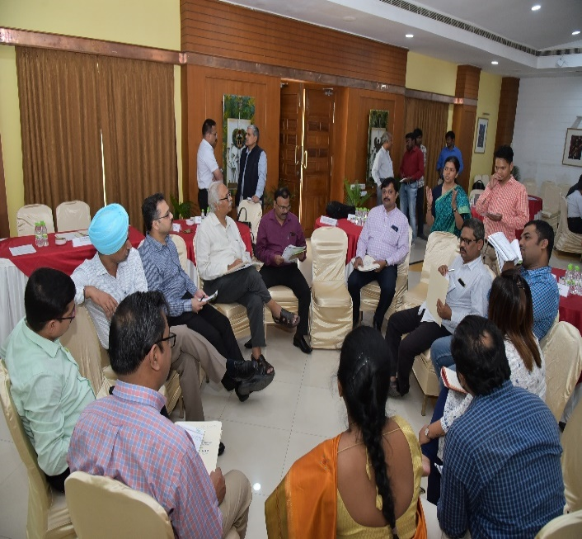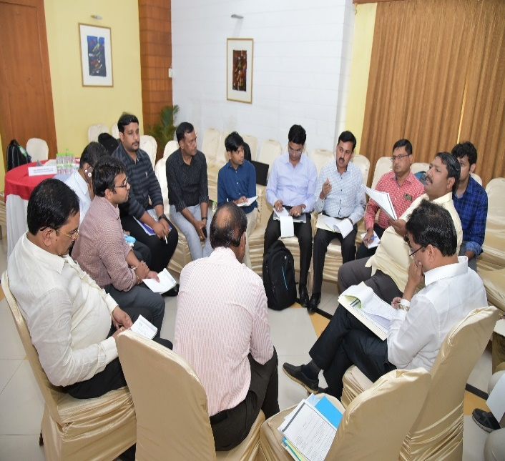
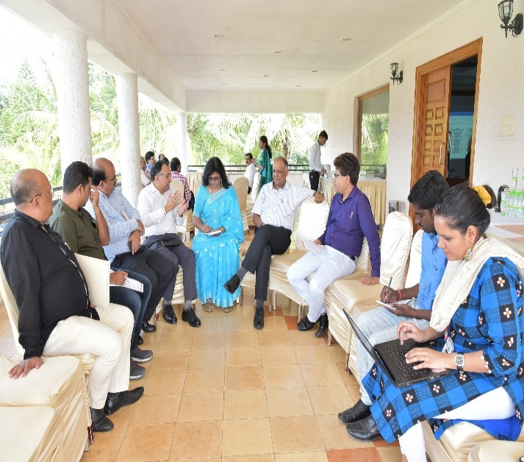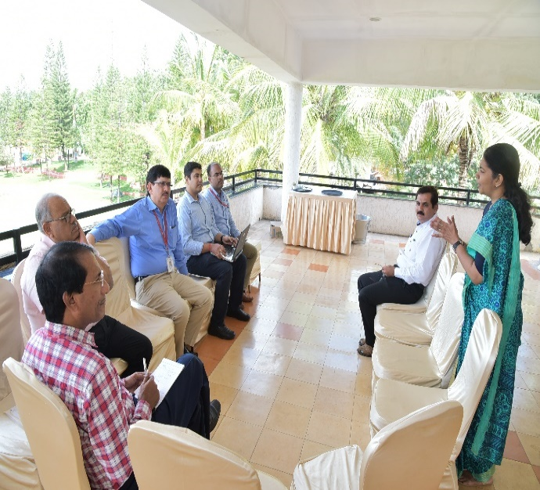
Glimpses of the four group discussions by the participants

Group - 1

Discussion Points

- Interdepartmental coordination for placement
- Coordination among MoRD, SRLM, CTSA, PIAs and SSCs on placement
- Unified platform of SSC, SRLM, MoRD and CTSA for placement
- Placement assessment for LoIs: PIA shall also verify the placement with proposed employers
- NABCONS & NIRD to undertake skill gap analysis at national level
- Industry involvement- Industry to own a batch and trained candidate as per job requirement from the day 1 of training.
- Barefoot staff of various dept shall also be involved in mobilization
- Consider placing trained candidates as barefoot staff
- Industry internship
- Relook at policies of industry and MSMEs
- PIAS and SRLMS to have dedicated placement cells
- DDUGKY Guidelines to be relooked
- SRLM shall act as mediating partner b/w placements and assessment
- Coordination b/w various SRLMs and MOU for interstate placement
- Methodology to decrease woman dropout
- Placement cell and vacancy bank at district and state level
- KAUSHAL PANJEE – To be used extensively for feeding available jobs
- During the batch freezing motivational sessions or activities to be performed
- CRP to be involved in placement tracking
- Interest inventory for interest of the candidate

Refer to Appendix fifteen for the powerpoint

Group - 2

Action Points

- Trainers from Industry
- Up skilling of trained candidates
- Meeting of employers
- Focus on ToT
- Jobs at panchayats level
- Quality improvement
- Institution mechanism for mobilization through referral basis
- Identification of Job Roles- New Areas, New technologies
- New initiatives- should come into the discussion with states
- Grading of trainers
- Alumni should be more unitized
- Domain trainers have to come from the industry
- Work readiness program, Finishing school for work ethics
- Agriculture- Searching of Job at panchayat & block level, list of agri. Industry,
- To set up call centre
- PIA wise industry connects
- Relaxation for captive employers
Refer to Appendix sixtenen for the powerpoint

Group - 3

Bold Steps for the next few months

- PIA should have clarity about the job roles of the candidates so that his/her orientation should be done accordingly from Day 1 of Mobilization
- OJT should be done in the beginning of the Training programme
- PIA should prioritize local candidates from SHG and then members of SHG families should be given priority
- Effective Industry connect should be established at each State
- Placement period (3 months) needs to be adapted depending on the duration of training for better retention of candidates
- Placement Verification should be done twice after the placement – at different intervals and instalment release should be linked to this
- Industry should be encouraged to become PIAs, wherever possible, and flexibility in SOP should be given
- There should be more stake of Candidates and PIAs in the programmes: Margin money
- OJT Report card should be used where candidates take feedback from Employer which Trainer can use to improve the skills of candidates
- Every staff in SRLM must maintain connect with at least 5 Employers
- Convergence among the diff. govt. departments (line departments), wherever needed- state specific e.g. Bamboo association in NE can be leveraged for candidate placements.
- Local industry placement has to be encouraged
- Each Ministry Official should adopt some States
- SSCs assessments are getting delayed and affecting the entire process. Timelines should be established for the SSCs and they should be complied
- Use of technologies must be leveraged by States for screening of candidate at mobilization stage

Refer to Appendix seventeen for the powerpoint

Group - 4

Recommendations - Way Forward
- Meeting/Workshops of SSCs, Industry representatives, SRLMs, MoRD and PIAs with a focus to inform the industry partners about the skill development initiatives and the objective of meeting their skill demands through relevant training interventions
- Let SSCs be invited in the PAC meeting of the states while awarding projects to PIAs to ensure training happens in job roles where placement opportunities exist or likely to arise
- DDU-GKY scheme need to adopt National Apprenticeship Promotional Scheme (NAPS) as one of the interventions
- Minimum requirement of 576 hours of training in DDU-GKY is suggested to be, if required, divided into several modular courses delivered over a period of time to provide flexibility for candidates to complete the training on part time / weekend basis
- A comprehensive Skill Gap Analysis Framework needs to be developed centrally to be used by PIAs and States for assessing demand and training need accordingly
- To fulfill the minimum requirement of 576 hours of training in DDU-GKY, whenever primary job role fall shorts of minimum required hours, the ancillary job role is suggested to be picked up from Professional and Entrepreneurship Skill Council to increase the Probability & Employability of the Candidates
- Job roles in the industry sector like CGSSC, PCS etc., where high capital expenditure is required for training, it is suggested that either NAPS/Industry Internship Training Programme be promoted OR the state government should set up the infrastructure and invite prospective PIAs to conduct the training from there
- Explore the implementation of a predictive model for assessing the probability of drop out of a candidate during mobilization – like what we heard from TATA Strive
- To improve the placement ratio in DDU-GKY, it is suggested that SRLM/MoRD should talk to different Govt. departments/ organizations to place DDU-GKY trained candidates by their service partners in outsourced functions like Housekeeping, security, paramedical, Hospitality, Logistics, DEOs etc
- A mechanism needs to be devised to share the Best practices amongst SRLMs and PIAs for improved implementation of DDU-GKY
Refer to Appendix eighteen for the powerpoint
Summary of the Gaps identified by each group
- Interdepartmental coordination for placement
- Coordination among MoRD, SRLM, CTSA, PIAs and SSCs on placement
- Consider placing trained candidates as barefoot staff
- Industry internship
- Coordination between various SRLMs and MOU for interstate placement
- Placement cell and vacancy bank at district and state level
- Interest inventory for interest of the candidate
- Trainers from industry
- Meeting of employers
- Jobs at panchayat levels
- Quality improvement
- Institution mechanism for mobilization through referral basis
- Grading of trainers
Summary of 5 bold steps for the next 6 months
- Placement assessment for LoIs: PIA shall also verify the placement with proposed employers
- Industry involvement: Industry to own a batch and trained candidate as per job requirement from the day one of training.
- Unified platform of SSC, SRLM, MoRD and CTSA for placement
- Barefoot staff of various department shall also be involved in mobilization
- Relook at policies of industry and MSMEs
- PIAS and SRLMS to have dedicated placement cells
- SRLM shall act as mediating partner between placements and assessment
- Methodology to decrease woman dropout
- Kaushal Panjee to be used extensively for feeding available jobs
- During the batch freezing motivational sessions or activities to be performed
- CRP to be involved in placement tracking
- Up skilling of trained candidates
- Focus on ToT
- Identification of job roles, new areas, new technologies
- New initiatives should come into discussion with states
- Domain trainers have to come from industry
- Alumni should be more unitized
- To set up call centre
- Relaxation for captive employers
- PIA should have clarity about the job roles of the candidates so that his/her orientation should be done accordingly from Day 1 of Mobilization
- OJT should be done in the beginning of the Training programme
- PIA should prioritize local candidates from SHG and then members of SHG families should be given priority
- Effective Industry connect should be established at each State
- Placement period (3 months) needs to be adapted depending on the duration of training for better retention of candidates
- Placement Verification should be done twice after the placement – at different intervals and instalment release should be linked to this
- Industry should be encouraged to become PIAs, wherever possible, and flexibility in SOP should be given
- There should be more stake of Candidates and PIAs in the programmes: Margin money
- OJT Report card should be used where candidates take feedback from Employer which Trainer can use to improve the skills of candidates
- Every staff in SRLM must maintain connect with at least 5 Employers
- Convergence among the diff. govt. departments (line departments), wherever needed- state specific e.g. Bamboo association in NE can be leveraged for candidate placements.
- Local industry placement has to be encouraged
- Each Ministry Official should adopt some States
- SSCs assessments are getting delayed and affecting the entire process. Timelines should be established for the SSCs and they should be complied
- Use of technologies must be leveraged by States for screening of candidate at mobilization stage
- Meeting/Workshops of SSCs, Industry representatives, SRLMs, MoRD and PIAs with a focus to inform the industry partners about the skill development initiatives and the objective of meeting their skill demands through relevant training interventions
- Let SSCs be invited in the PAC meeting of the states while awarding projects to PIAs to ensure training happens in job roles where placement opportunities exist or likely to arise
- Job roles in the industry sector like CGSSC, PCS etc., where high capital expenditure is required for training, it is suggested that either NAPS/Industry Internship Training Programme be promoted OR the state government should set up the infrastructure and invite prospective PIAs to conduct the training from there
- Explore the implementation of a predictive model for assessing the probability of drop out of a candidate during mobilization – like what we heard from TATA Strive
Support required from MoRD and NIRDR
- NABCONS & NIRD to undertake skill gap analysis at national level
- DDU-GKY Guidelines to be relooked
- DDU-GKY scheme need to adopt National Apprenticeship Promotional Scheme (NAPS) as one of the interventions
- Minimum requirement of 576 hours of training in DDU-GKY is suggested to be, if required, divided into several modular courses delivered over a period of time to provide flexibility for candidates to complete the training on part time / weekend basis
- A comprehensive Skill Gap Analysis Framework needs to be developed centrally to be used by PIAs and States for assessing demand and training need accordingly
- To fulfill the minimum requirement of 576 hours of training in DDU-GKY, whenever primary job role fall shorts of minimum required hours, the ancillary job role is suggested to be picked up from Management, Professional and Entrepreneurship Skill Council to increase the Probability & Employability of the Candidates
- To improve the placement ratio in DDU-GKY, it is suggested that SRLM/MoRD should talk to different Govt. departments/ organizations to place DDU-GKY trained candidates by their service partners in outsourced functions like Housekeeping, security, paramedical, Hospitality, Logistics, DEOs etc
- A mechanism needs to be devised to share the Best practices amongst SRLMs and PIAs for improved implementation of DDU-GKY

Session 9: Best Practices and Challenges in Placement – Voice of the States

Chair: Dr. B. R. Mamatha, IAS, Mission Director, Karnataka
Presentation by Assam
Refer to Appendix nineteen for the powerpoint
Presentation by Andhra Pradesh
Refer to Appendix twenty for the powerpoint
Presentation by Bihar
Refer to Appendix twenty one for the powerpoint
Presentation by Haryana
Refer to Appendix twenty two for the powerpoint
Presentation by J&K
Refer to Appendix twenty three for the powerpoint
Presentation by Karnataka
Refer to Appendix twenty four for the powerpoint
Presentation by Kerala
Refer to Appendix twenty five for the powerpoint
Presentation by Telangana
Refer to Appendix twenty six for the powerpoint
Presentation by Uttar Pradesh
Refer to Appendix twenty seven for the powerpoint
Presentation by West Bengal
Refer to Appendix twenty eight for the powerpoint

Remarks by the Chair: Dr. B R Mamatha, IAS, Mission Director, Karnataka
- State wise best practices highlighted by the chair.
- Everyone agreed to involve community persons in mobilization process
- Field exposure during batch freezing to avoid drop out
- Setting up of Call Centre
- Creating Pool of trainers
- Skill DEED
- Concentrate on IEC using social media where collectors and deputy collectors are involved during mobilization
- Door to Sandesh
- Convergence of SHG and DDU-GKY
- Alumni meets to be conducted

Session 10: Recommendations from MoRD by Shri Charanjit Singh, Joint Secretary (Skills), MoRD
- Objective is same to make DDU-GKY successful scheme
- To change the life cycle of a person we move the person from rural poverty to urban centre by making them to earn their livelihood is a big challenge
- MoRD, NIRDPR, NABCONS, SRLM and others have to address all the challenges as a united team

Session 11: Concluding Remarks and Way Forward by Director General, Dr W. R Reddy
- The vision should be creating a few lakhs of happy families not just giving small jobs. The great thing will be when these youngsters go out for work, settle down, get married and have proper career
- Continuously innovate, connect and collaborate with large number of agencies like SCC
- Intensive engagement with industry
- Combination of QPs and trades could be a way forward
- Groom and train large number of trainers
- Look at skilling holistically
- Apprenticeship-based learning, NAPS to be explored
- We need to understand why there is a trust deficit once a PIA-trained and SSC assessed candidate comes out
- Skill gap analysis needs to be reliable, dynamic and concurrent
- For CAPEX-heavy job roles, can we leverage CSR
- There should be smooth data flow between SSCs, SRLMs
- Sector-wise workshop should be conducted with SRLMs and PIAs
- There is a need to orient the PIAs on which trades are to be promoted
- Time has come to move to evidence based approach like in Tata STRIVE. The tools they are using serves the data to see what is working and what not is working
- Look for the interventions based on the evidences for which we have to come on a common platform for data capturing, data aggregation and then moving for analytics
- Kaushal Bharat should be on boarded by all the states. Link up of all the data to be done by their ERP and Kaushal Bharat
- After getting adequate data make a team for analytics for feedback and inputs for better implementations for this scheme
- Handholding and proper care to be taken for the PIAs to move the activities ahead and for better improvement

Session 12: Felicitation of Guests
Director General, Dr W. R Reddy presented memento to all the guests.

Vote of Thanks by Shri Shankar Dutt Kabdal, Director - M&E, DDU-GKY, NIRDPR
Shri Shankar Dutt Kabdal, Director (M&E) proposed a vote of thanks for the guidance provided by Director General NIRDPR, Joint Secretary (Skills) MoRD, to all the participants of the conclave and all those involved in logistics and arrangement to make this conclave a success.

Appendix
- (Click here to view the presentation)
- (Click here to view the presentation)
- (Click here to view the presentation)
- (Click here to view the presentation)
- (Click here to view the presentation)
- (Click here to view the presentation)
- (Click here to view the presentation), (Click here to view the presentation)

- (Click here to view the presentation)

- (Click here to view the presentation)

- (Click here to view the presentation)

- (Click here to view the presentation)

- (Click here to view the presentation)

- (Click here to view the presentation)
- (Click here to view the presentation), (Click here to view the PDF), (Click here to view the video)

- (Click here to view the presentation)
- (Click here to view the presentation)

- (Click here to view the presentation)
- (Click here to view the presentation)
- (Click here to view the presentation)
- (Click here to view the presentation)
- (Click here to view the presentation)
- (Click here to view the presentation)
- (Click here to view the presentation)
- (Click here to view the presentation)

- (Click here to view the presentation)
- (Click here to view the presentation)
- (Click here to view the presentation)
- (Click here to view the presentation)

Contact:
Training Division, DDU-GKY,
NIRD & PR
040 24001205
Trainingddugky.nird@gov.in

